GCP Terraform Static Website Deployment Report

Author: Aditya Saxena

Date: May 10, 2025

This report presents a complete walkthrough for deploying a static website using Terraform on Google Cloud Platform (GCP). It follows a logical step-by-step structure — from project and API setup to final teardown — with screenshots and detailed technical explanations for each step.

Table of Contents

Step 1.1 Creating New Project 5

Step 1.2 Creating New Project 6

Step 2.1 Check Terraform Version 7

Step 2.2 Intalling Hashicorp TAP 8

Step 2.3 Install Terraform 9

Step 3.1 Enabling API Cloud DNS 10

Step 3.2 Enabling API Cloud DNS 11

Step 3.3 Enabling API Compute Engine API 12

Step 3.4 Enabling API Compute Engine API 13

Step 3.5 Enabling API IAM API 14

Step 3.6 Enabling API IAM API 15

Step 4.1 Creating Service Account 16

Step 4.2 Creating Service Account 17

Step 4.3 Creating Service Account 18

Step 4.4 Creating Service Account 19

Step 5.1 Creating Key for Service Account 20

Step 5.2 Creating Key for Service Account 21

Step 6.1 Terraform Initialize 22

Step 6.2 Terraform Initialize 23

Step 6.3 Terraform Plan 24

Step 6.4 Terraform Plan 25

Step 6.5 Terraform Apply 26

Step 7.1 Terrform Apply Results 27

Step 7.2 Terraform Apply Results 28

Step 8.1 Changing MIME Type 29

Step 8.2 Javascript MIME Type 30

Step 8.3 CSS MIME Type 31

Step 8.4 Taint and Apply 32

Step 9.1 Result 33

Step 10.1 Configuring DNS 34

Step 10.2 Configuring DNS 35

Step 11.1 Terraform Init and Plan 36

Step 11.2 Terraform Plan 37

Step 11.3 Terraform Apply 38

Step 11.4 Changing Nameservers 39

Step 11.5 Terraform Apply Complete 40

Step 11.6 Checking DNS Propogation 41

Step 11.7 Checking Website in Production Environment 42

Step 11.8 Checking Free SSL Certificate 43

Step 11.9 Checking Load Balancer 44

Step 12.1 Terraform Destroy 45

Step 12.2 Terraform Destroy 46

Step 12.3 Terraform Destroy 47

Step 12.4 Terraform Destroy 48

Step 12.5 Terraform Destroy 49

Step 12.6 Terraform Destroy 50

Step 12.7 Terraform Destroy 51

Step 12.8 Terraform Destroy 52

## Step 1.1 Creating New Project

These screenshots show the creation of a new GCP project. This project will serve as the isolated environment for all resources related to the Terraform-managed website. A new project is important to ensure separation of concerns, traceability, and isolated billing for this infrastructure deployment.

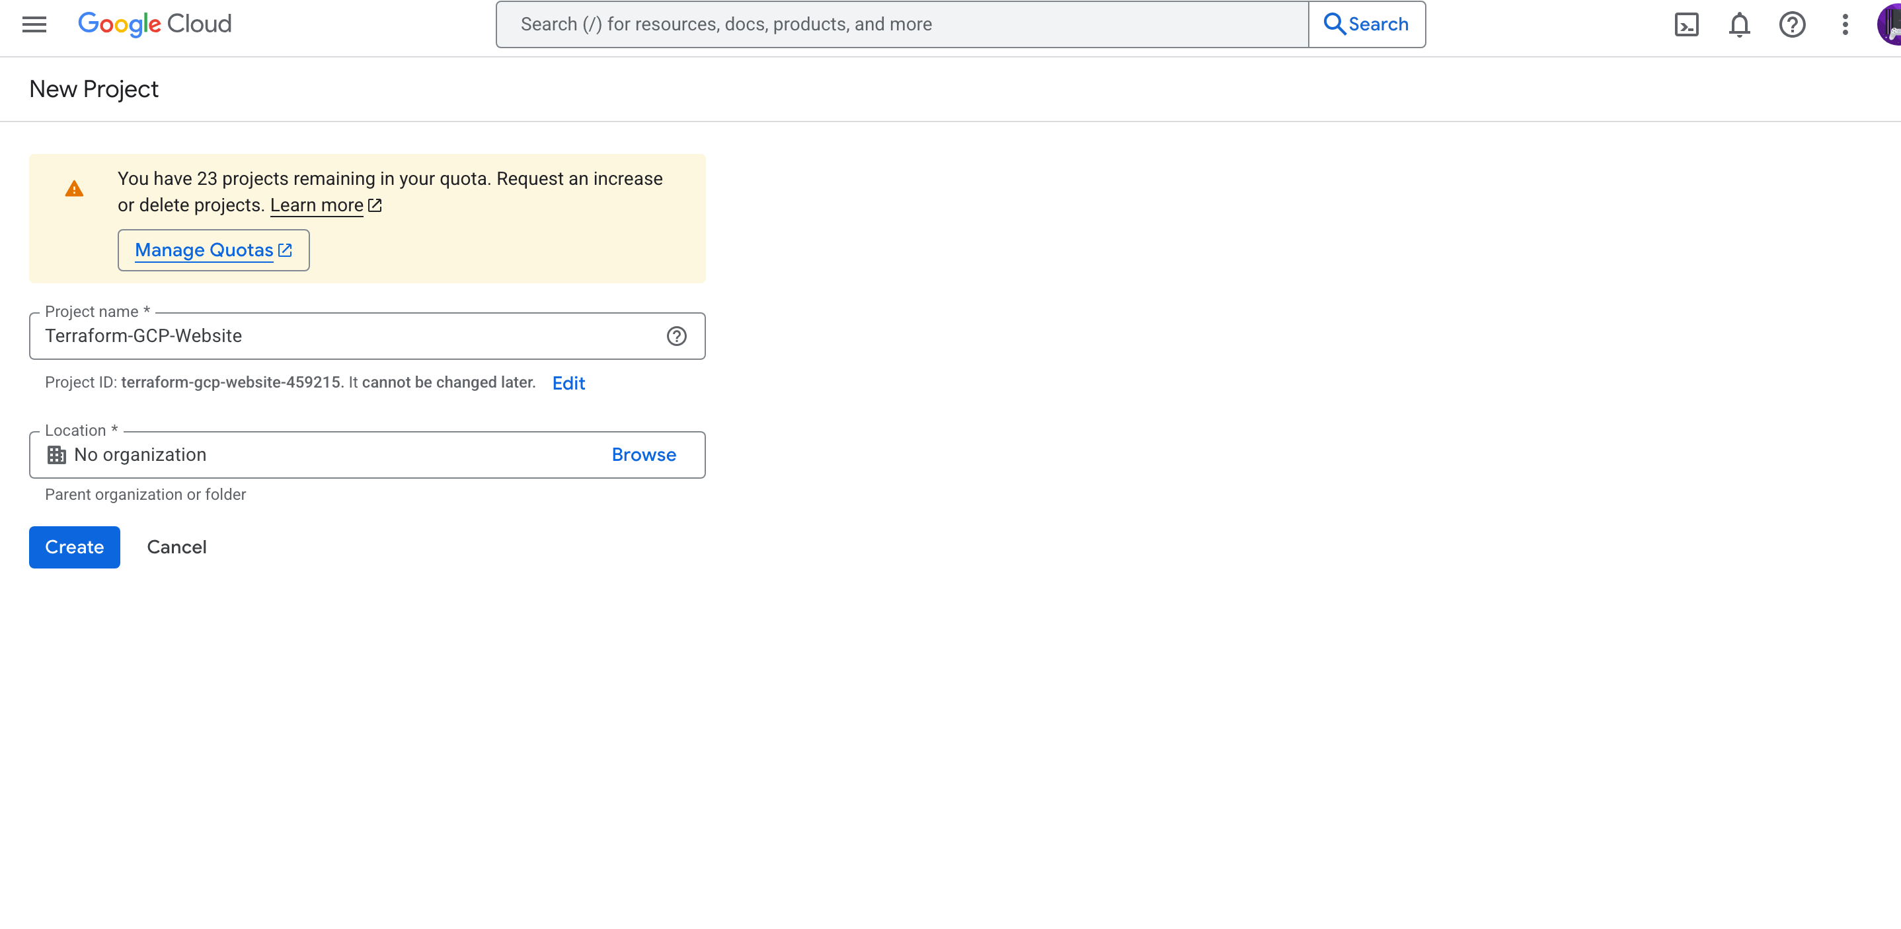

## Step 1.2 Creating New Project

These screenshots show the creation of a new GCP project. This project will serve as the isolated environment for all resources related to the Terraform-managed website. A new project is important to ensure separation of concerns, traceability, and isolated billing for this infrastructure deployment.



## Step 2.1 Check Terraform Version

We verify the installed version of Terraform using the CLI. Ensuring the correct version is installed is crucial for compatibility with Google Cloud provider plugins and avoiding configuration syntax mismatches.

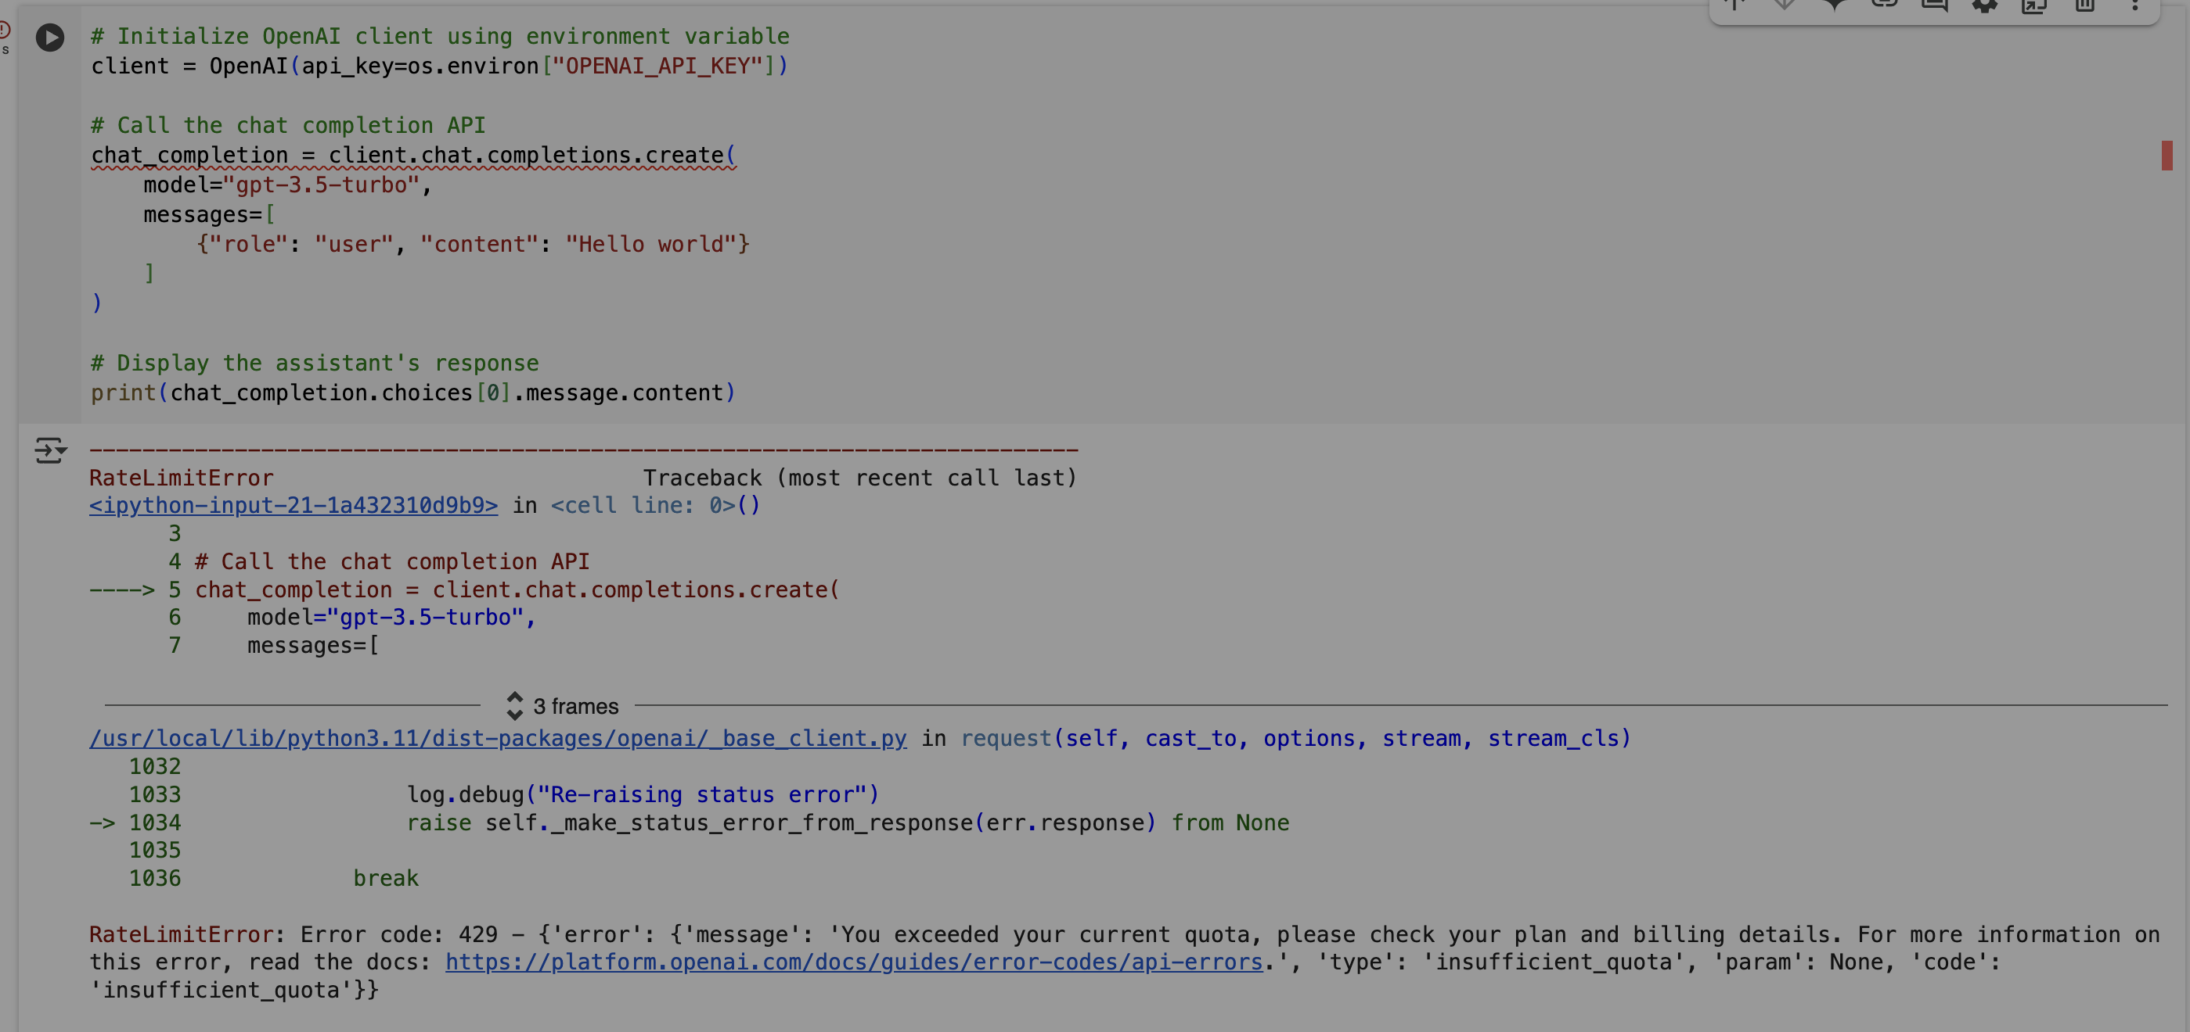

## Step 2.2 Intalling Hashicorp TAP

This screenshot represents an important step in the Terraform deployment workflow.

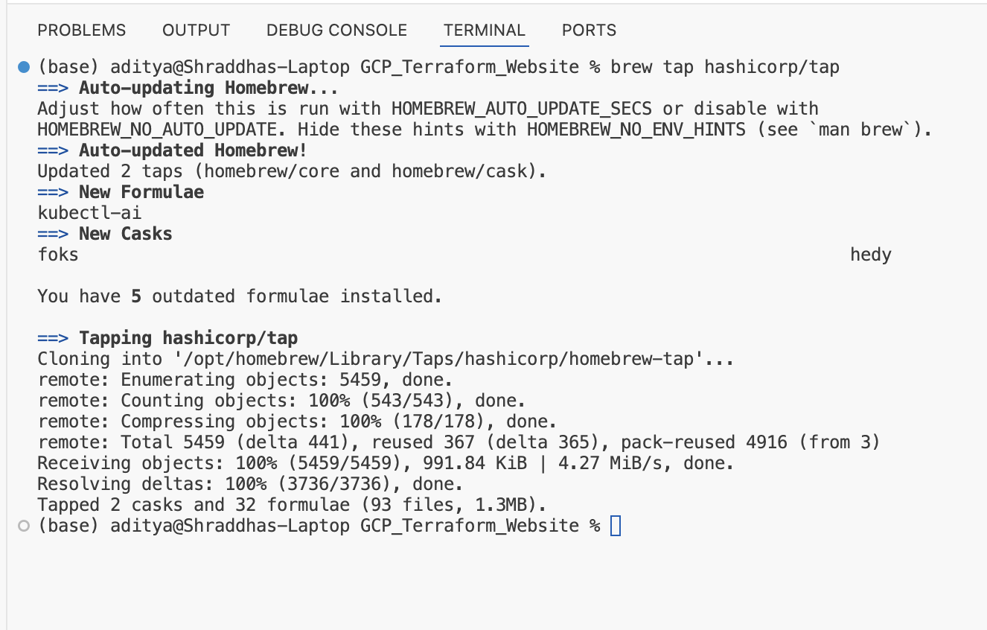

## Step 2.3 Install Terraform

Terraform is installed using the package manager. Terraform will be used to provision and manage GCP infrastructure via configuration files.

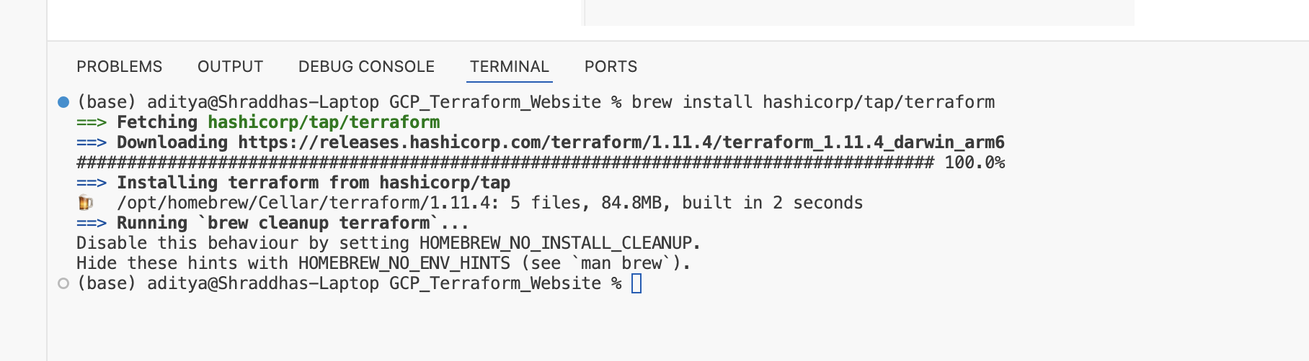

## Step 3.1 Enabling API Cloud DNS

Here, we enable key GCP APIs: Cloud DNS, Compute Engine, and IAM. These are essential for Terraform to create and manage DNS records, virtual machines, and roles.

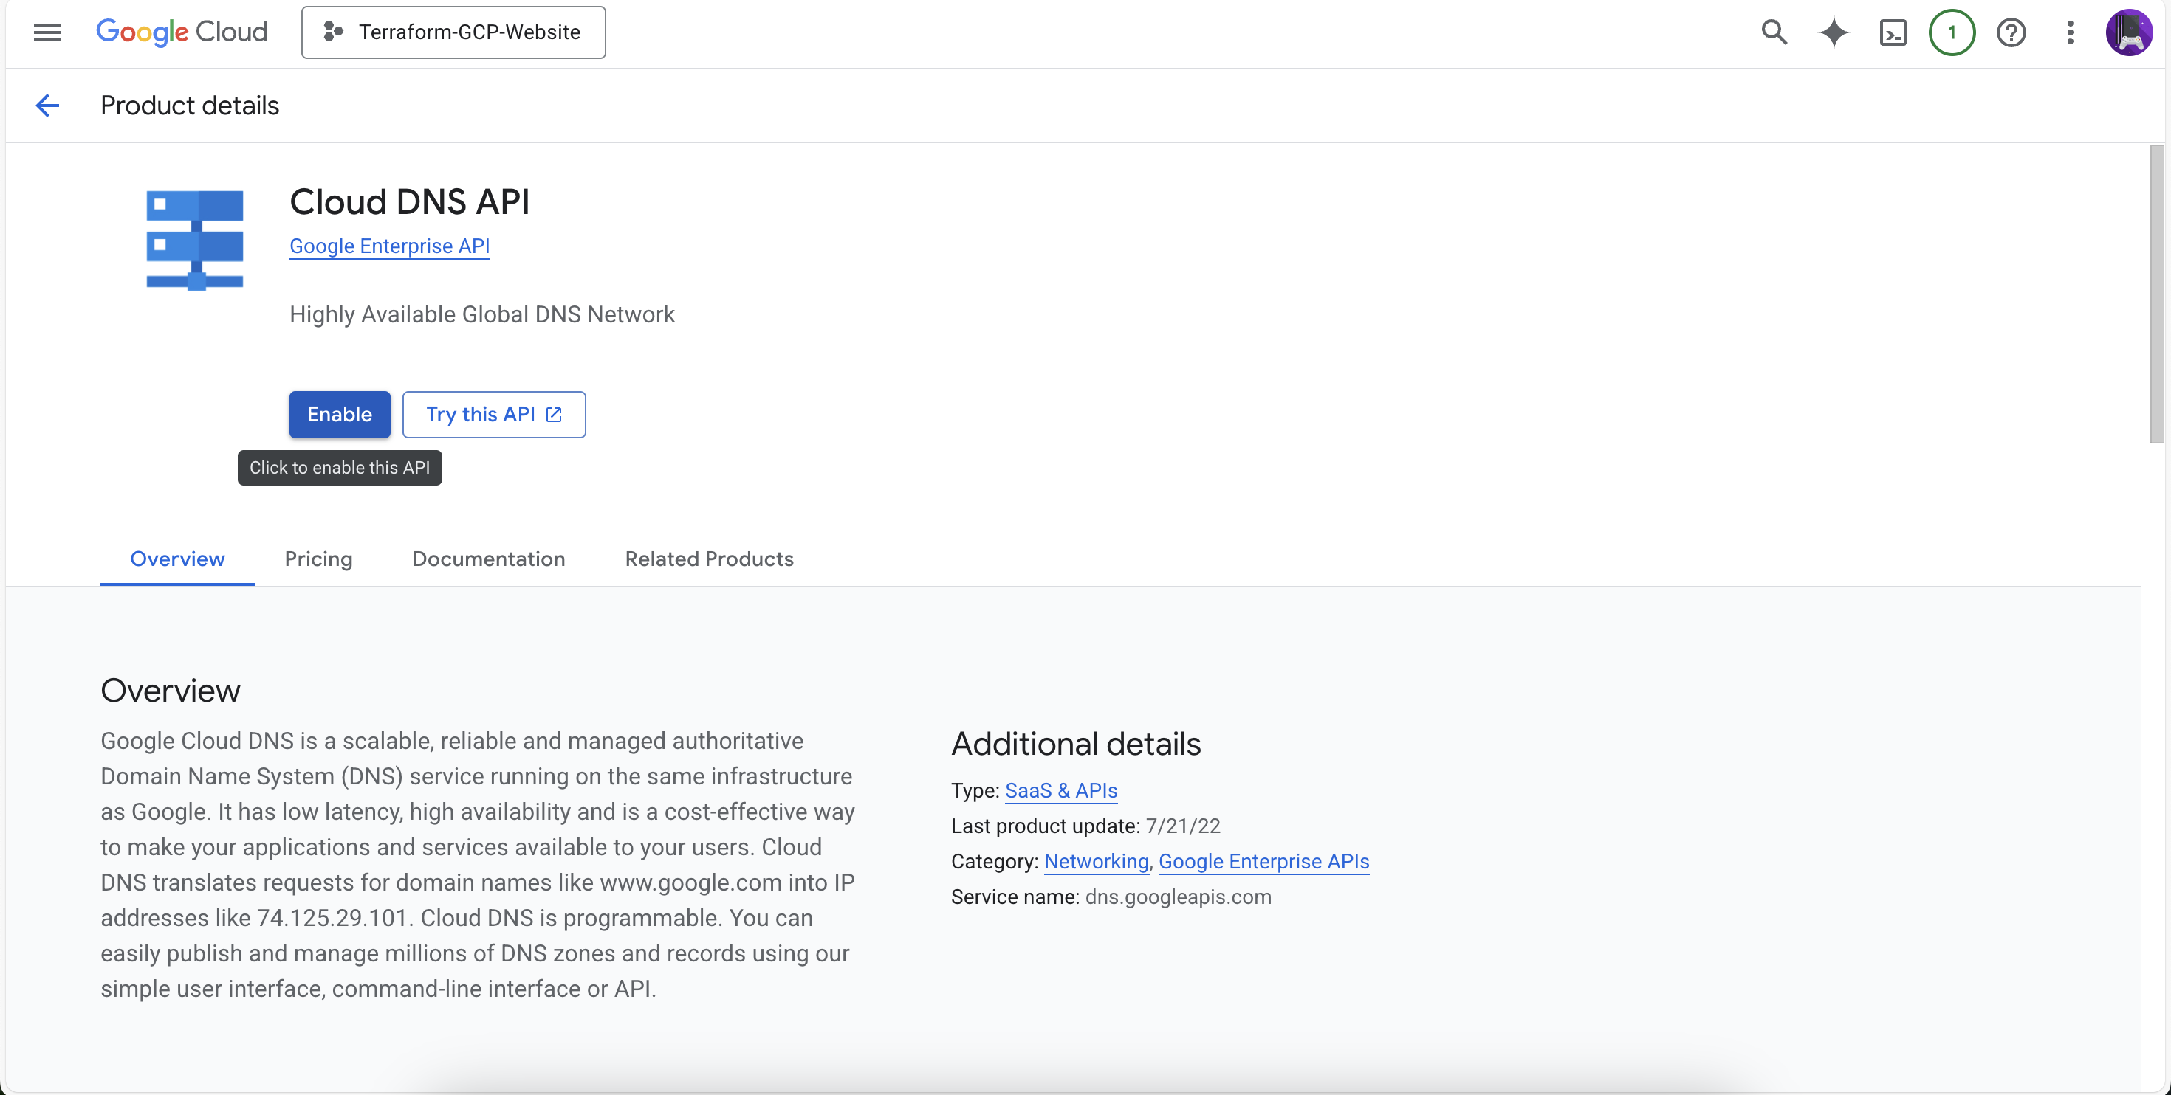

## Step 3.2 Enabling API Cloud DNS

Here, we enable key GCP APIs: Cloud DNS, Compute Engine, and IAM. These are essential for Terraform to create and manage DNS records, virtual machines, and roles.

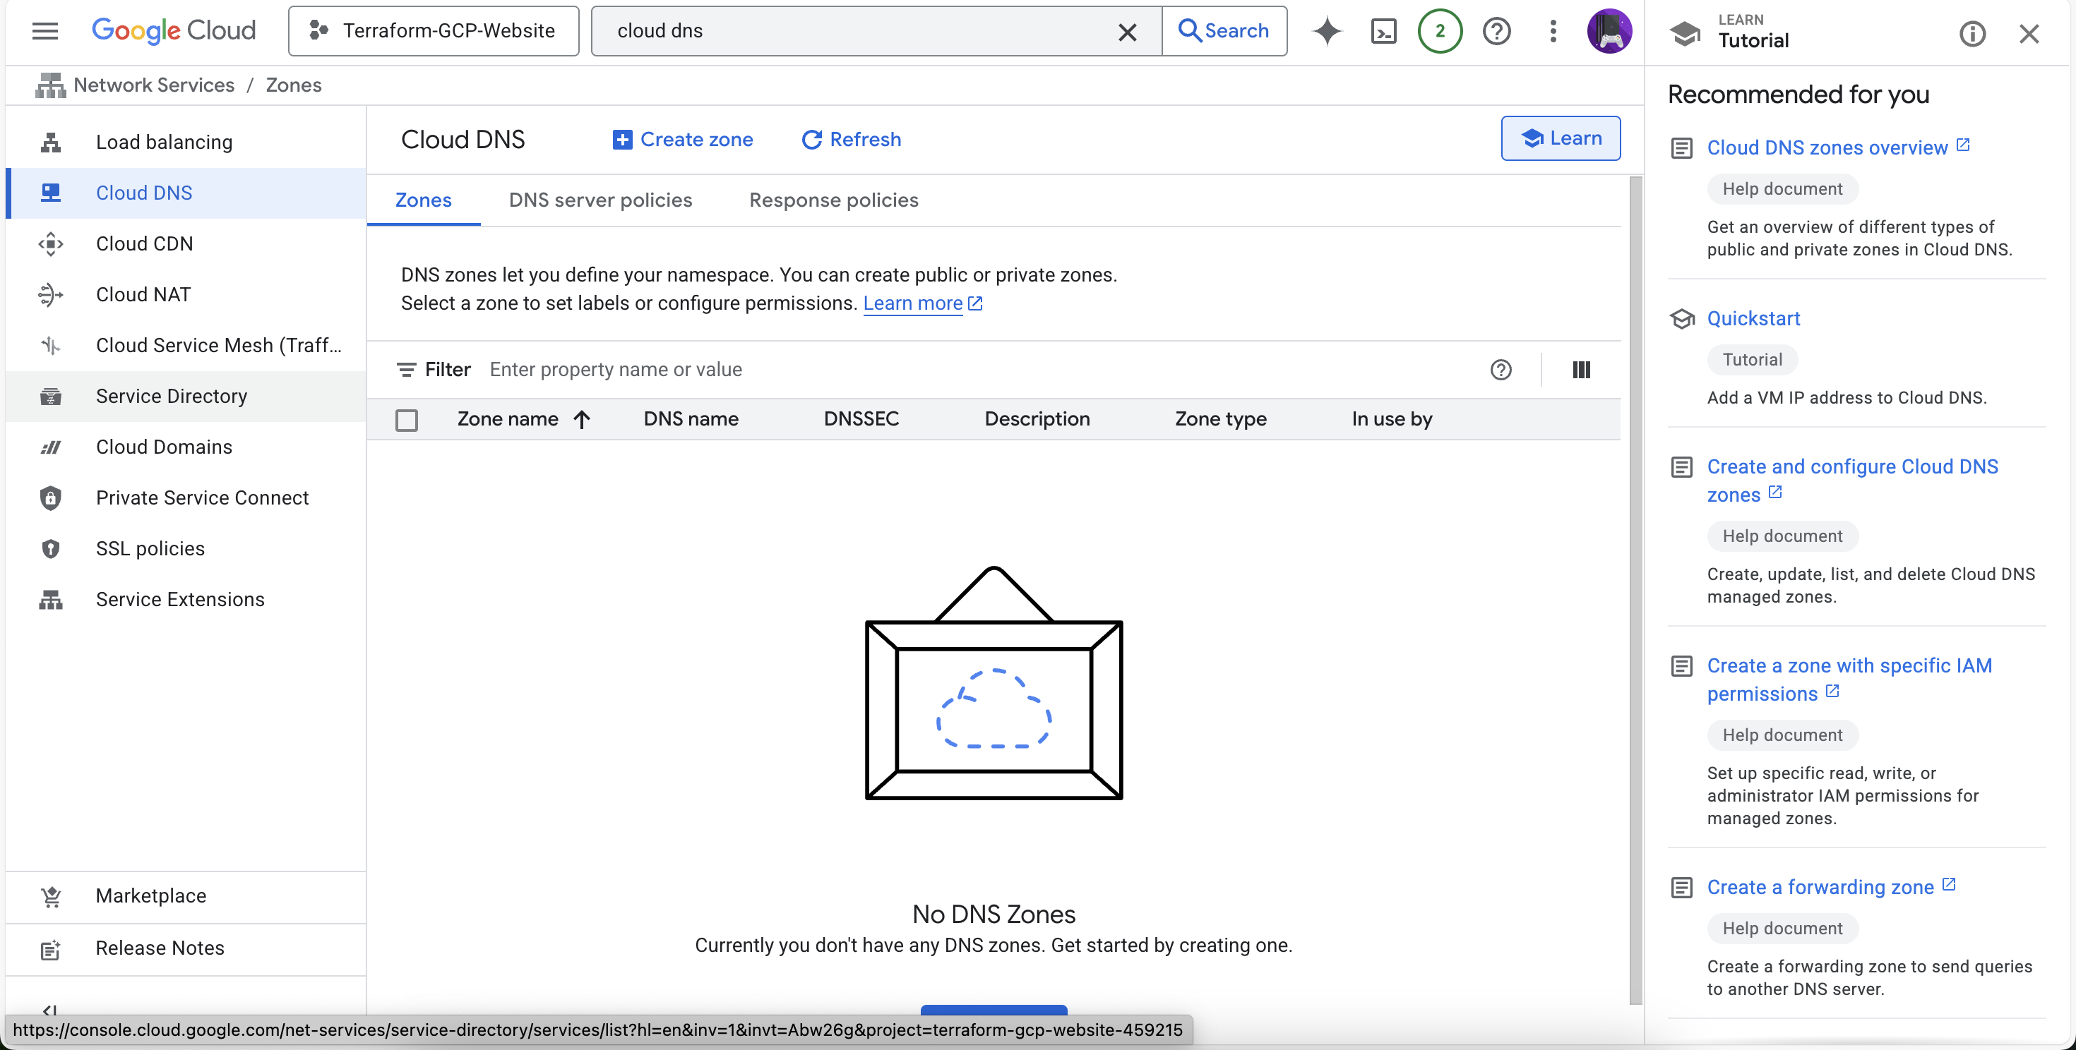

## Step 3.3 Enabling API Compute Engine API

Here, we enable key GCP APIs: Cloud DNS, Compute Engine, and IAM. These are essential for Terraform to create and manage DNS records, virtual machines, and roles.

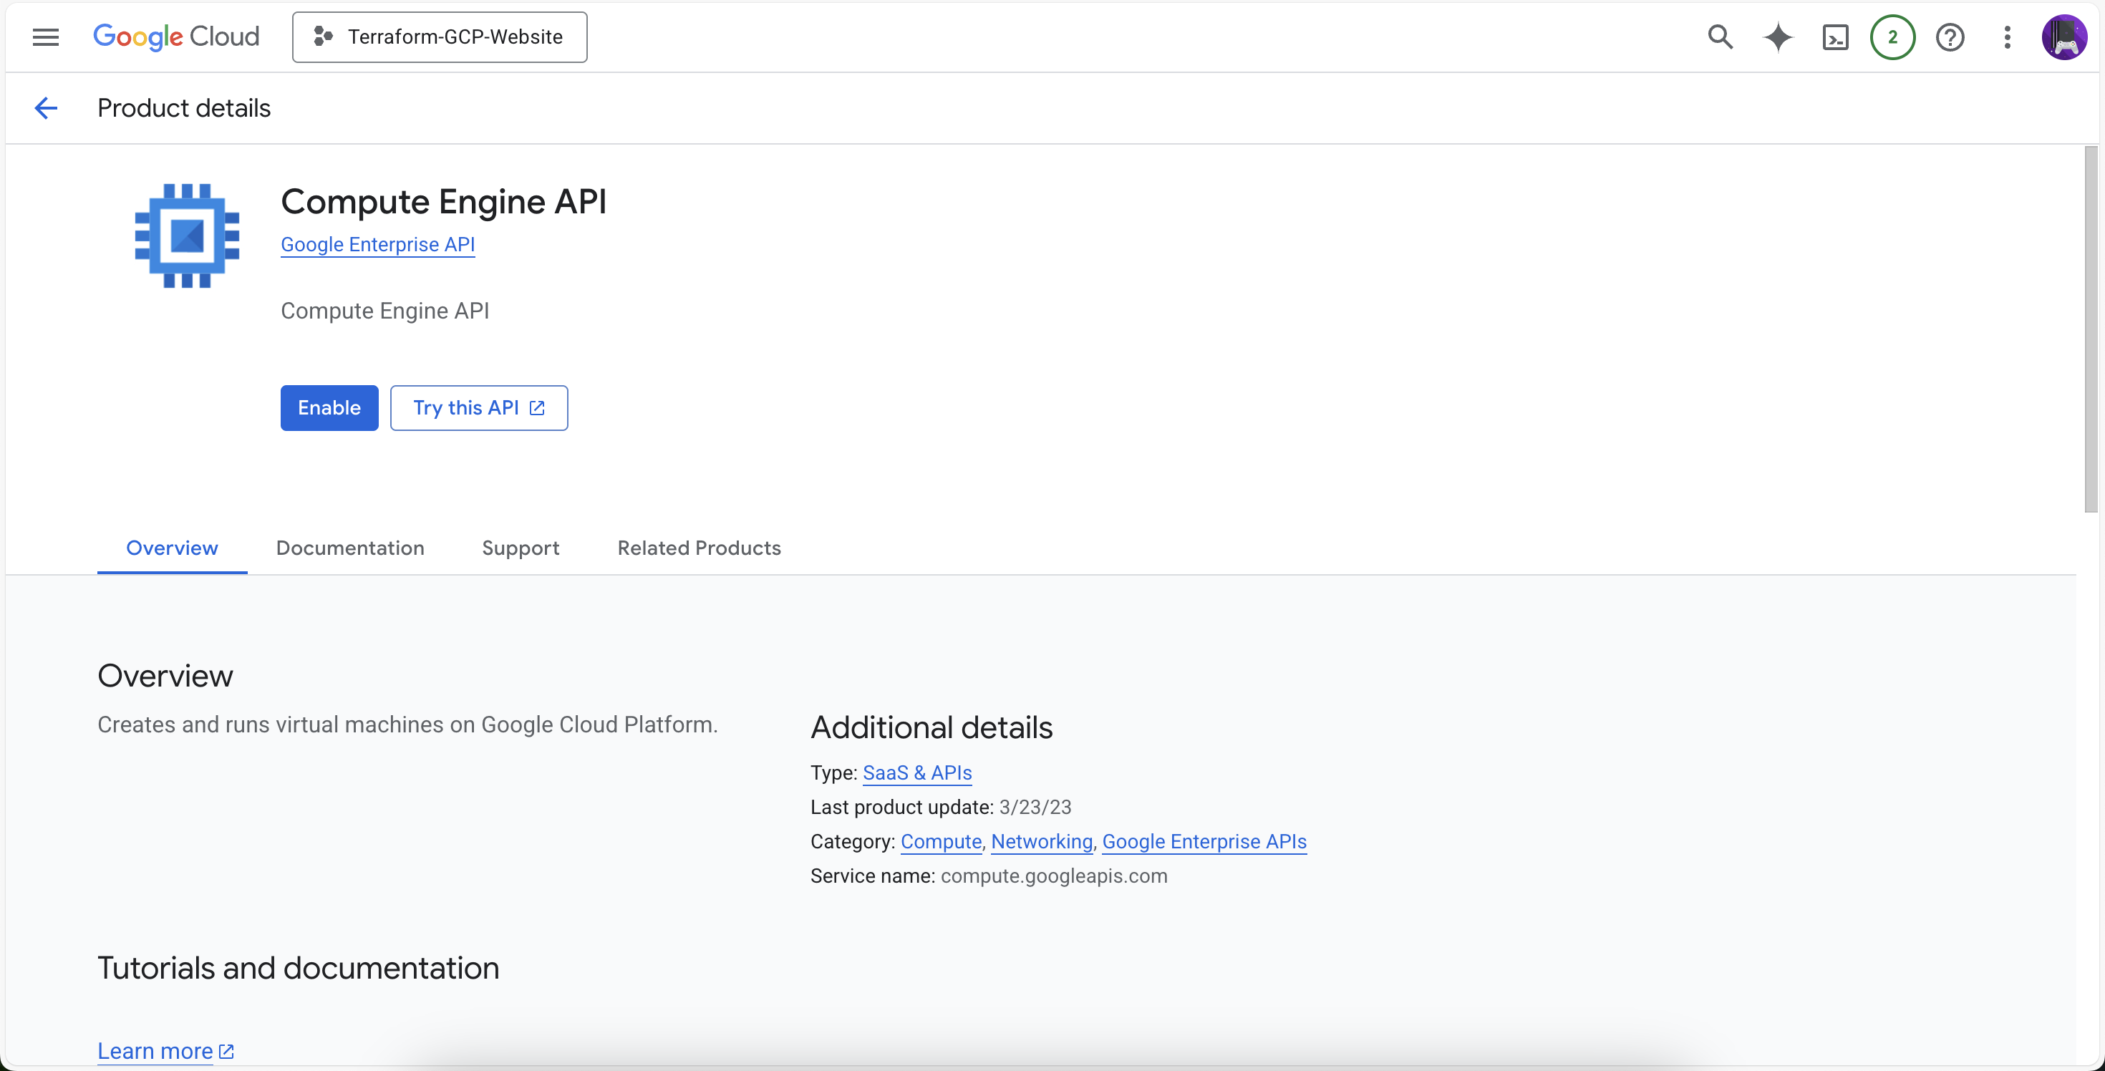

## Step 3.4 Enabling API Compute Engine API

Here, we enable key GCP APIs: Cloud DNS, Compute Engine, and IAM. These are essential for Terraform to create and manage DNS records, virtual machines, and roles.

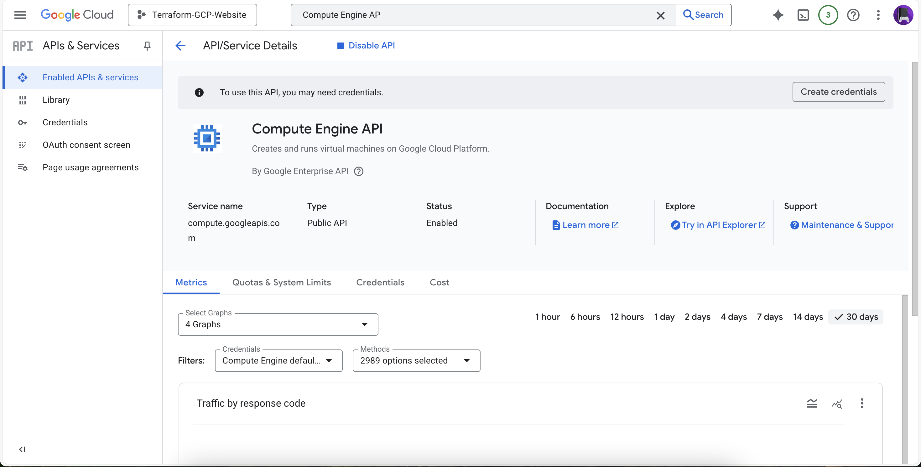

## Step 3.5 Enabling API IAM API

Here, we enable key GCP APIs: Cloud DNS, Compute Engine, and IAM. These are essential for Terraform to create and manage DNS records, virtual machines, and roles.



## Step 3.6 Enabling API IAM API

Here, we enable key GCP APIs: Cloud DNS, Compute Engine, and IAM. These are essential for Terraform to create and manage DNS records, virtual machines, and roles.



## Step 4.1 Creating Service Account

A dedicated service account is created with the necessary roles to manage the website infrastructure. This account allows Terraform to authenticate and execute tasks programmatically.

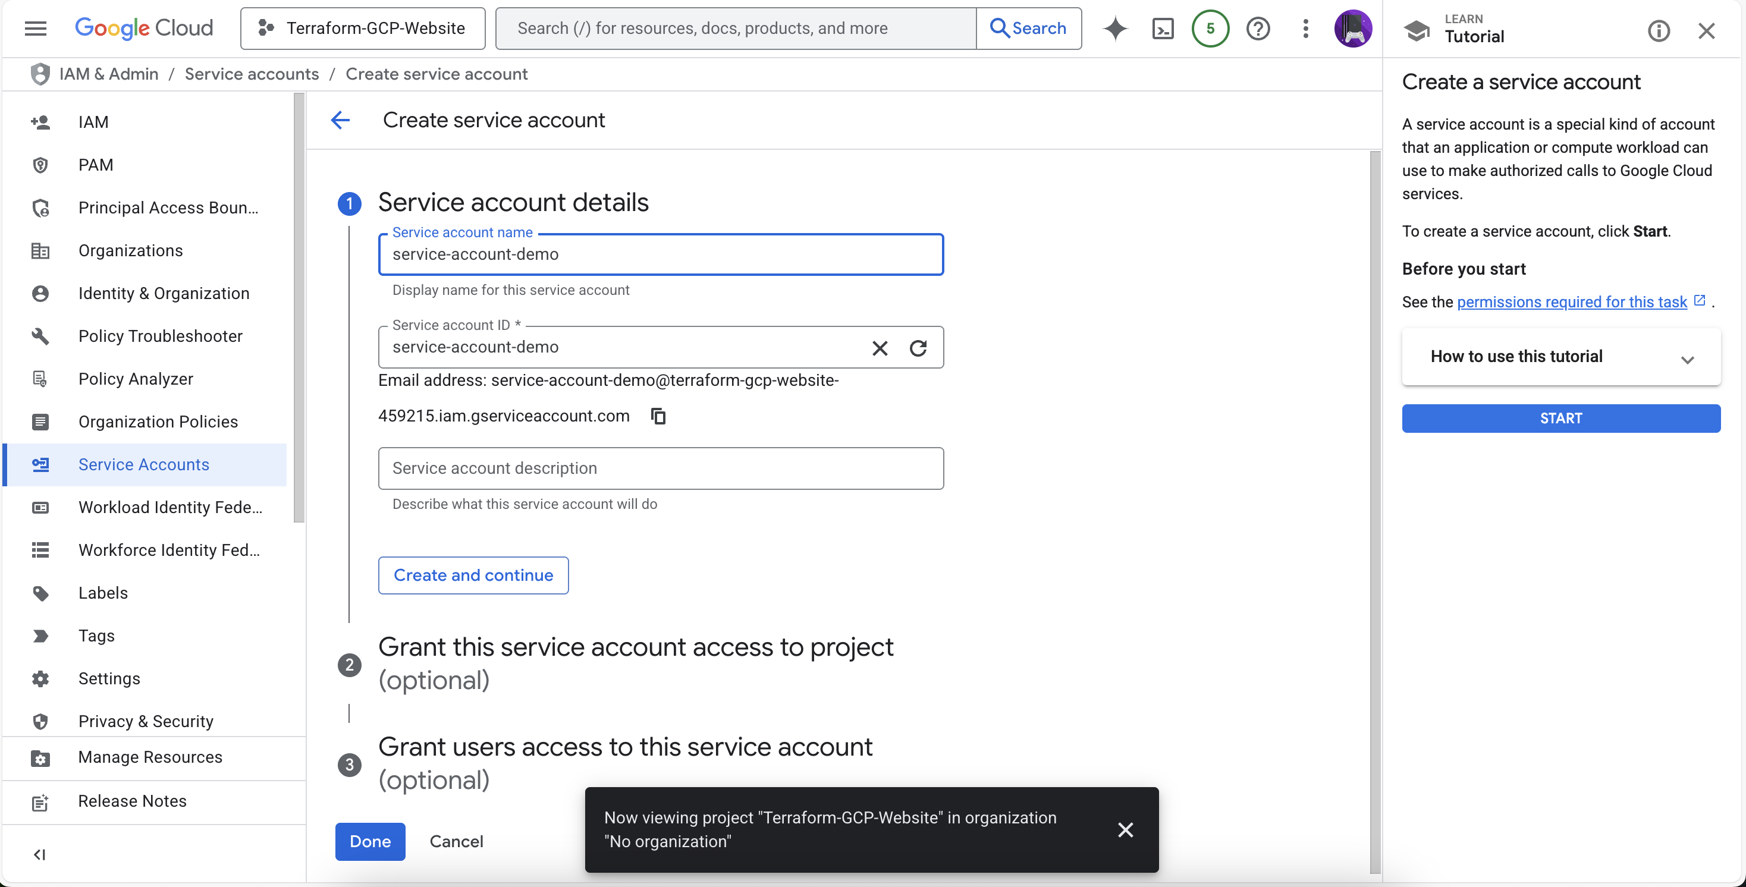

## Step 4.2 Creating Service Account

A dedicated service account is created with the necessary roles to manage the website infrastructure. This account allows Terraform to authenticate and execute tasks programmatically.

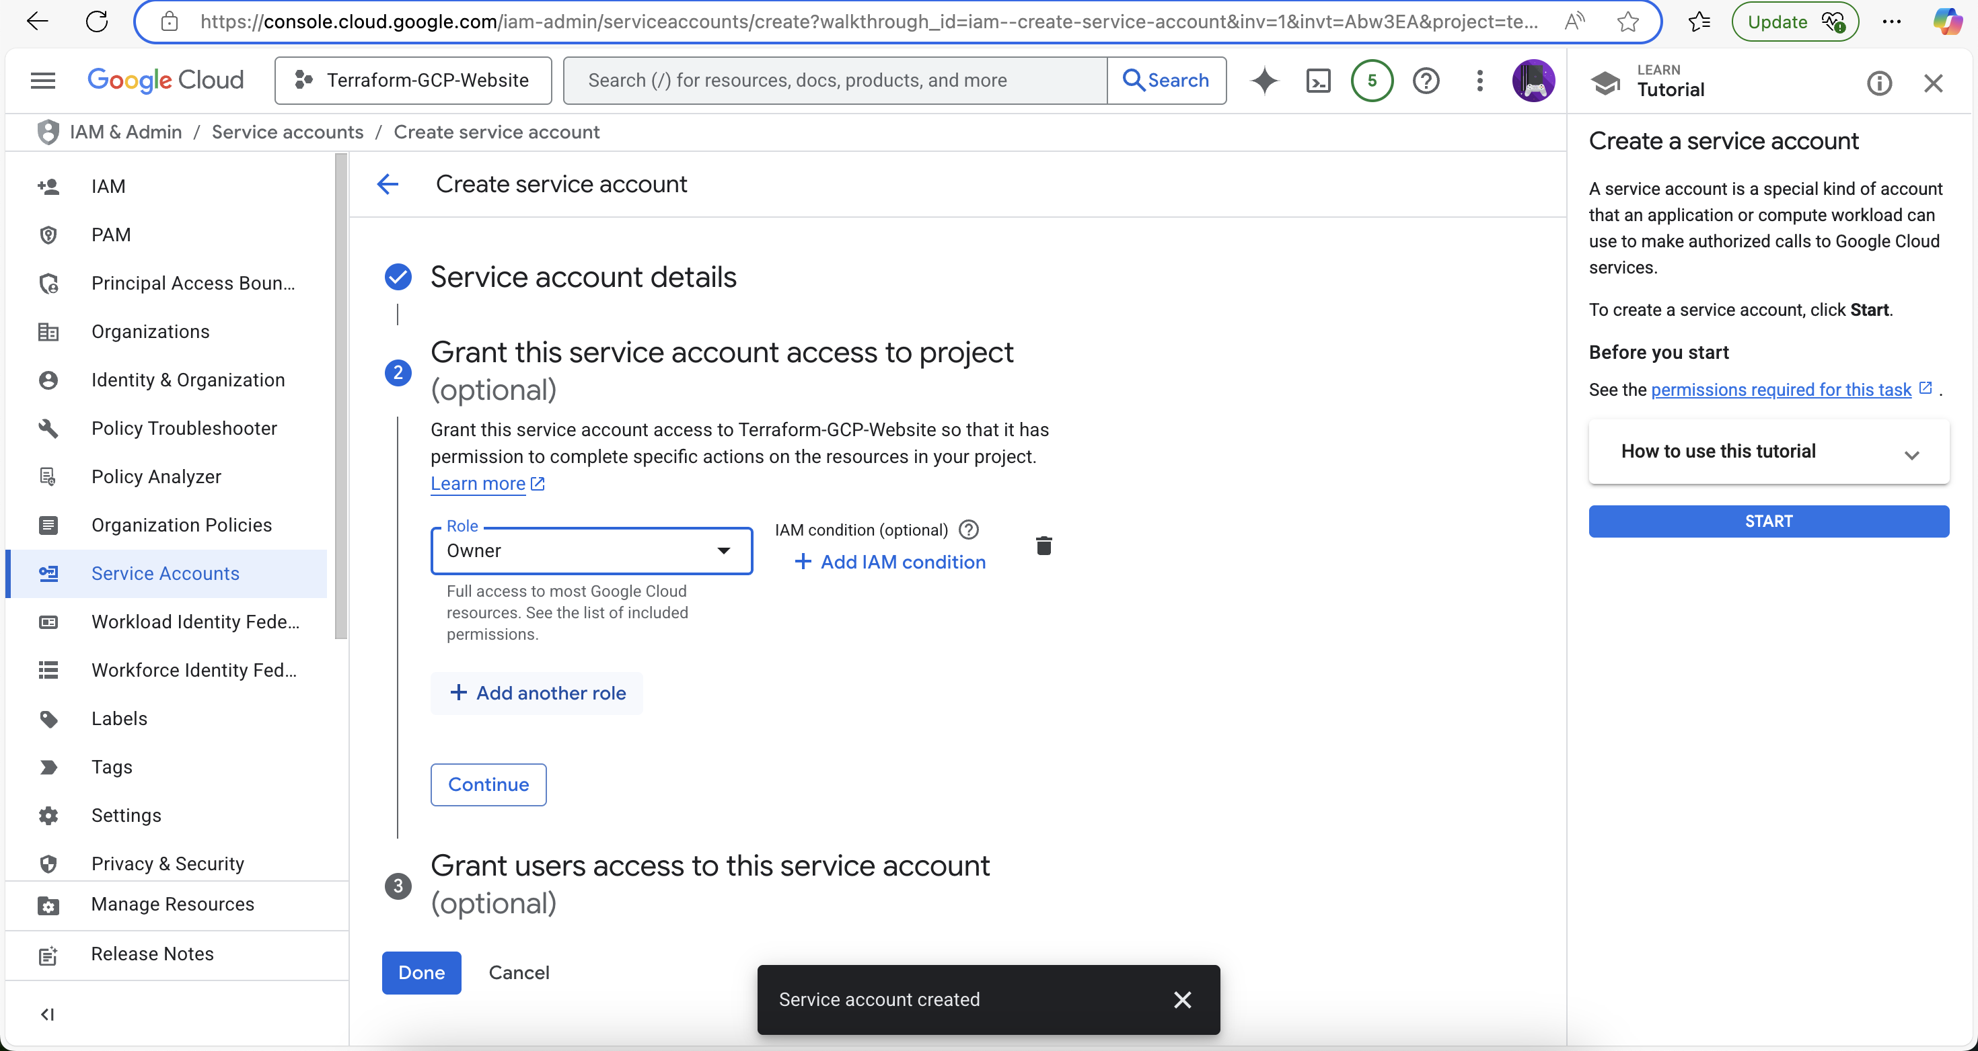

## Step 4.3 Creating Service Account

A dedicated service account is created with the necessary roles to manage the website infrastructure. This account allows Terraform to authenticate and execute tasks programmatically.

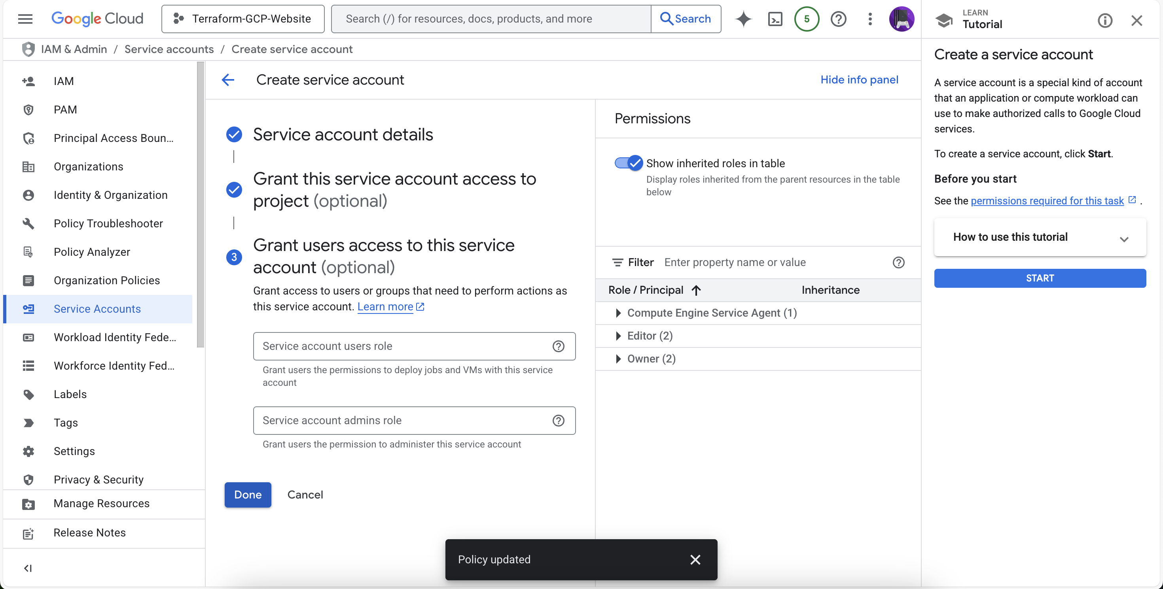

## Step 4.4 Creating Service Account

A dedicated service account is created with the necessary roles to manage the website infrastructure. This account allows Terraform to authenticate and execute tasks programmatically.



## Step 5.1 Creating Key for Service Account

We create and download a private key (JSON format) for the service account. This key will be used in Terraform provider configuration to authenticate the GCP API calls securely.

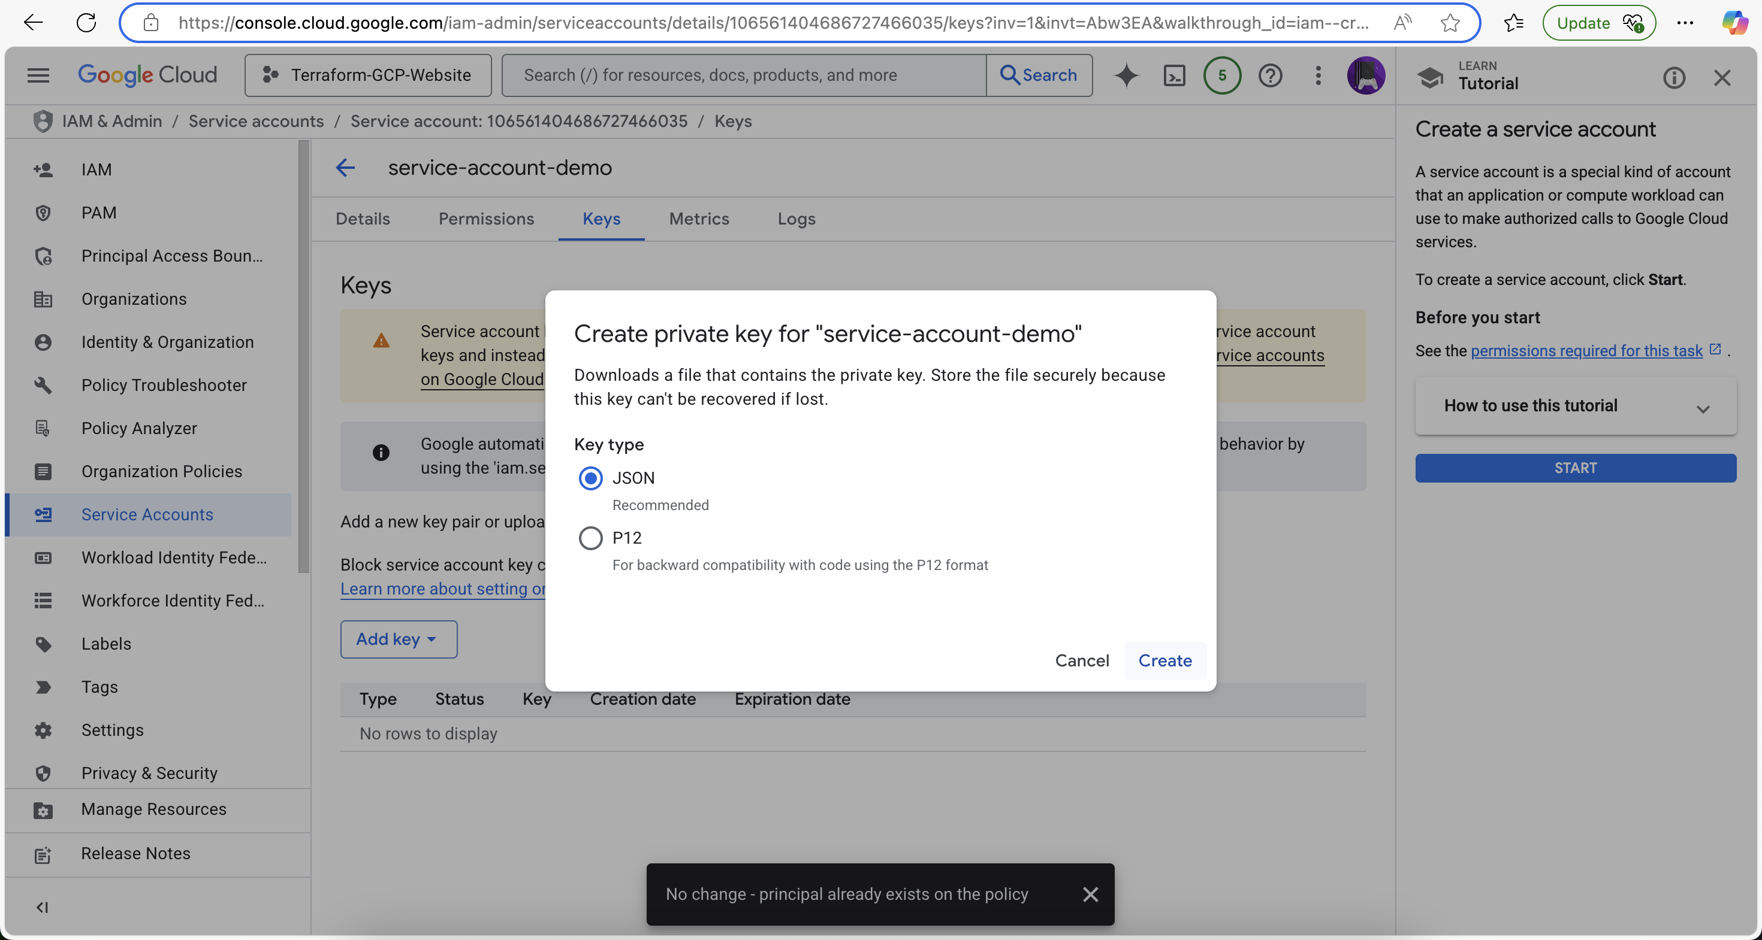

## Step 5.2 Creating Key for Service Account

We create and download a private key (JSON format) for the service account. This key will be used in Terraform provider configuration to authenticate the GCP API calls securely.



## Step 6.1 Terraform Initialize

`terraform init` initializes the working directory and downloads the Google provider plugin. This prepares the environment for Terraform to run properly.

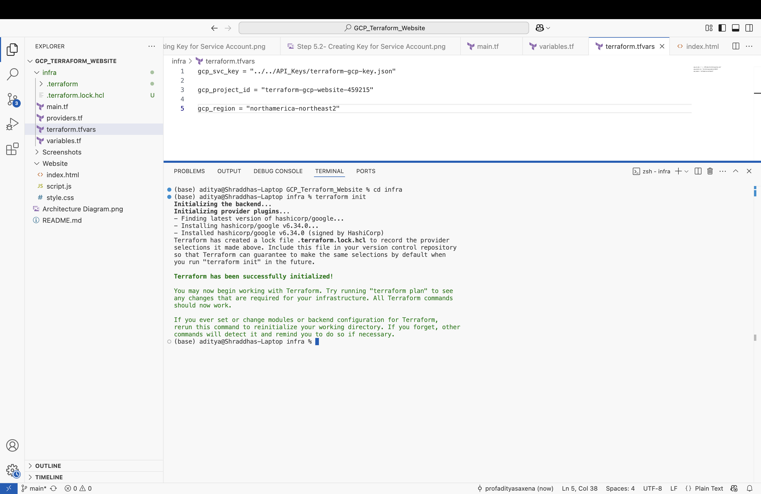

## Step 6.2 Terraform Initialize

`terraform init` initializes the working directory and downloads the Google provider plugin. This prepares the environment for Terraform to run properly.

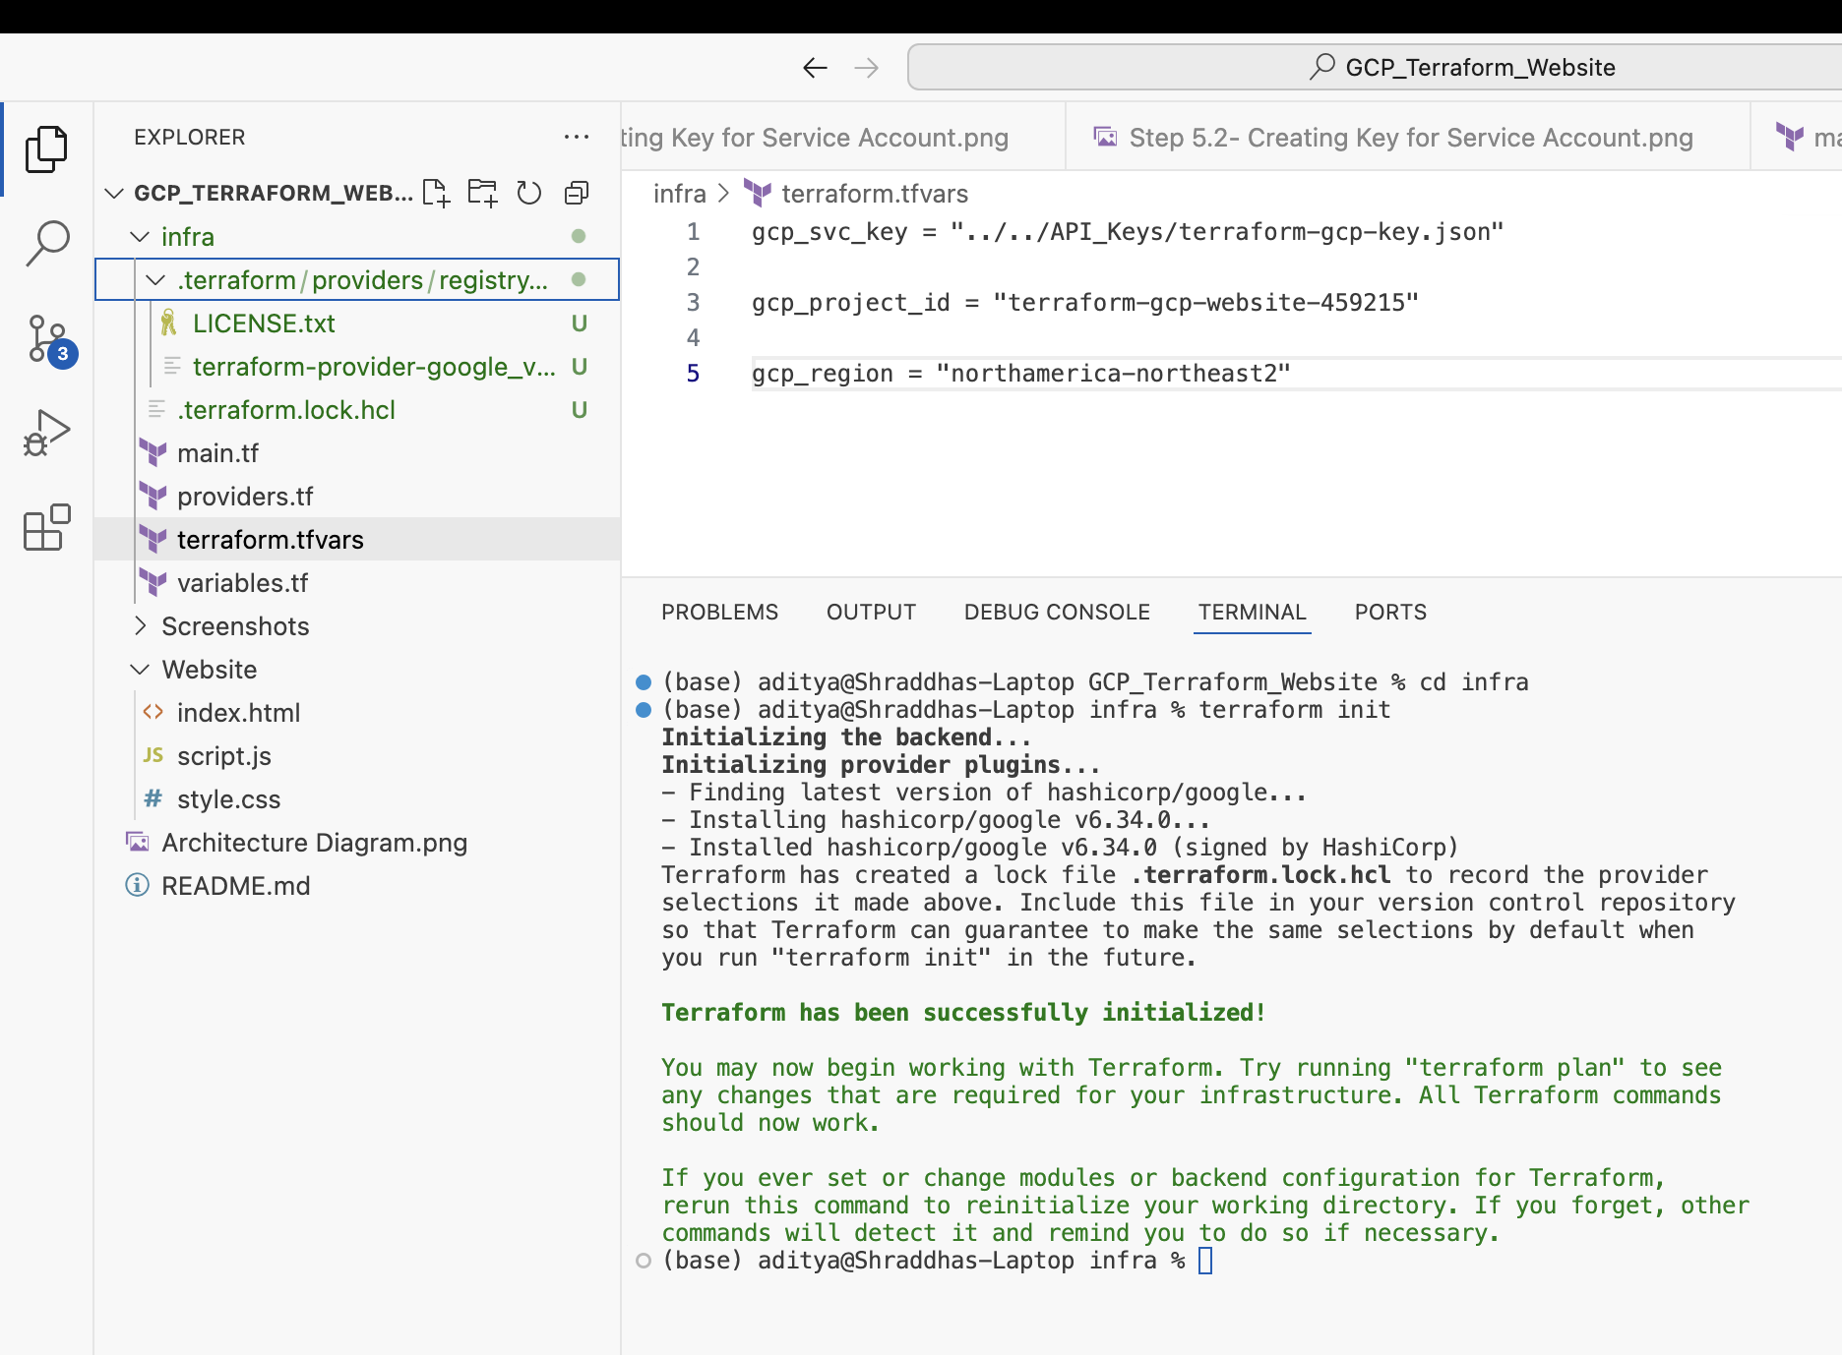

## Step 6.3 Terraform Plan

The `terraform plan` command is used to preview the infrastructure changes that will be applied. This helps catch potential errors before provisioning.

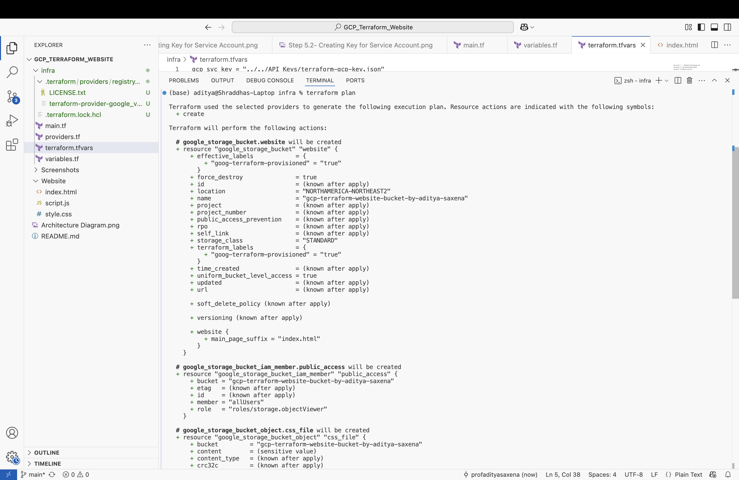

## Step 6.4 Terraform Plan

The `terraform plan` command is used to preview the infrastructure changes that will be applied. This helps catch potential errors before provisioning.

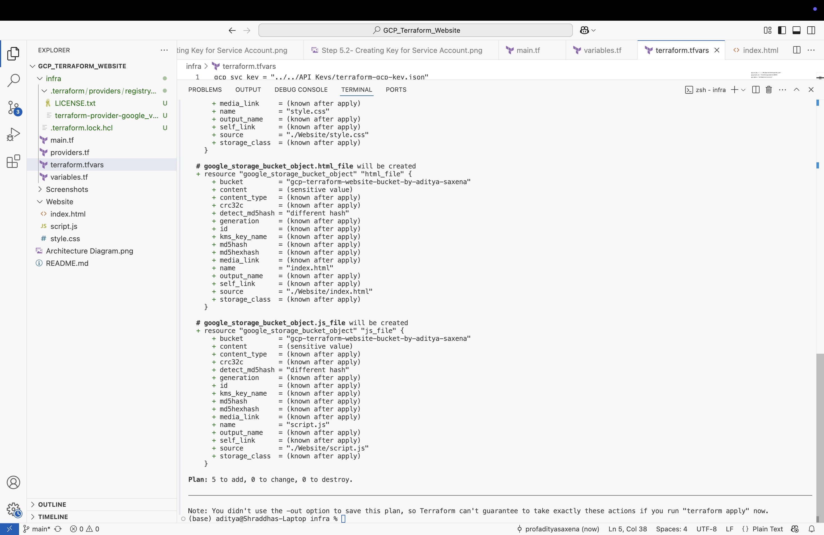

## Step 6.5 Terraform Apply

In this step, we run `terraform apply` to provision the actual resources. This includes setting up the storage bucket, IAM policies, CDN, and DNS configuration.

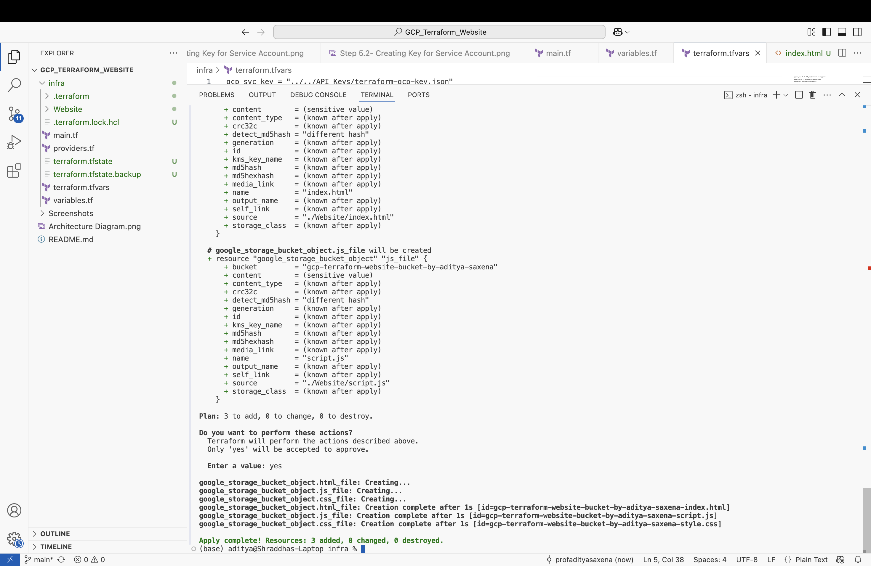

## Step 7.1 Terrform Apply Results

The output confirms successful creation of resources such as the backend bucket, load balancer, DNS records, and SSL certificates. We validate these results before moving forward.

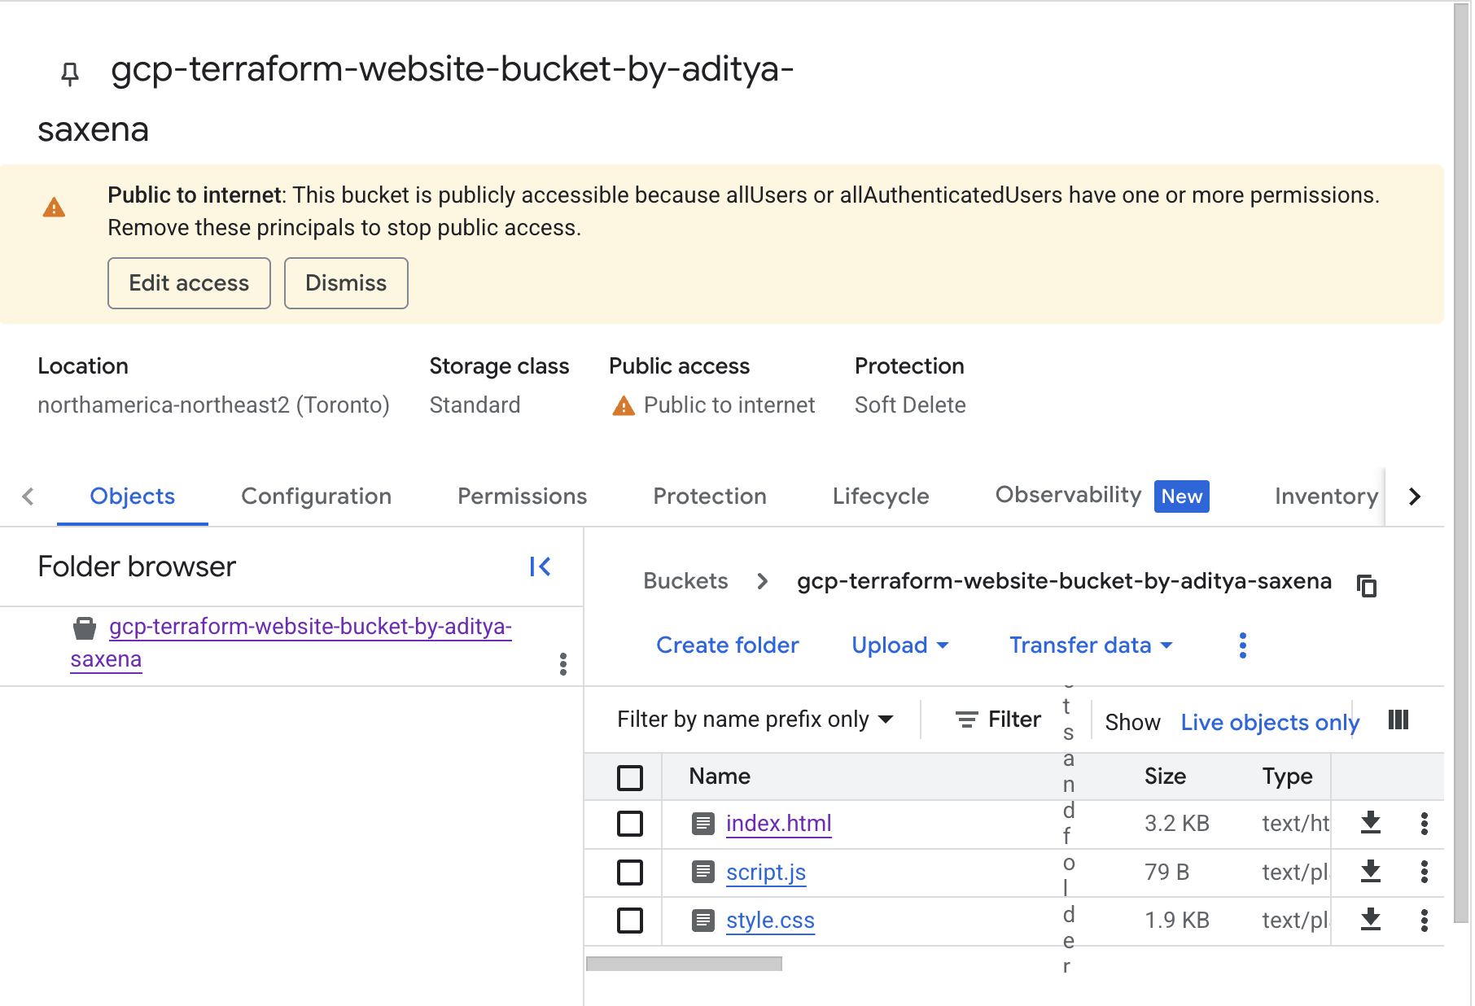

## Step 7.2 Terraform Apply Results

In this step, we run `terraform apply` to provision the actual resources. This includes setting up the storage bucket, IAM policies, CDN, and DNS configuration.

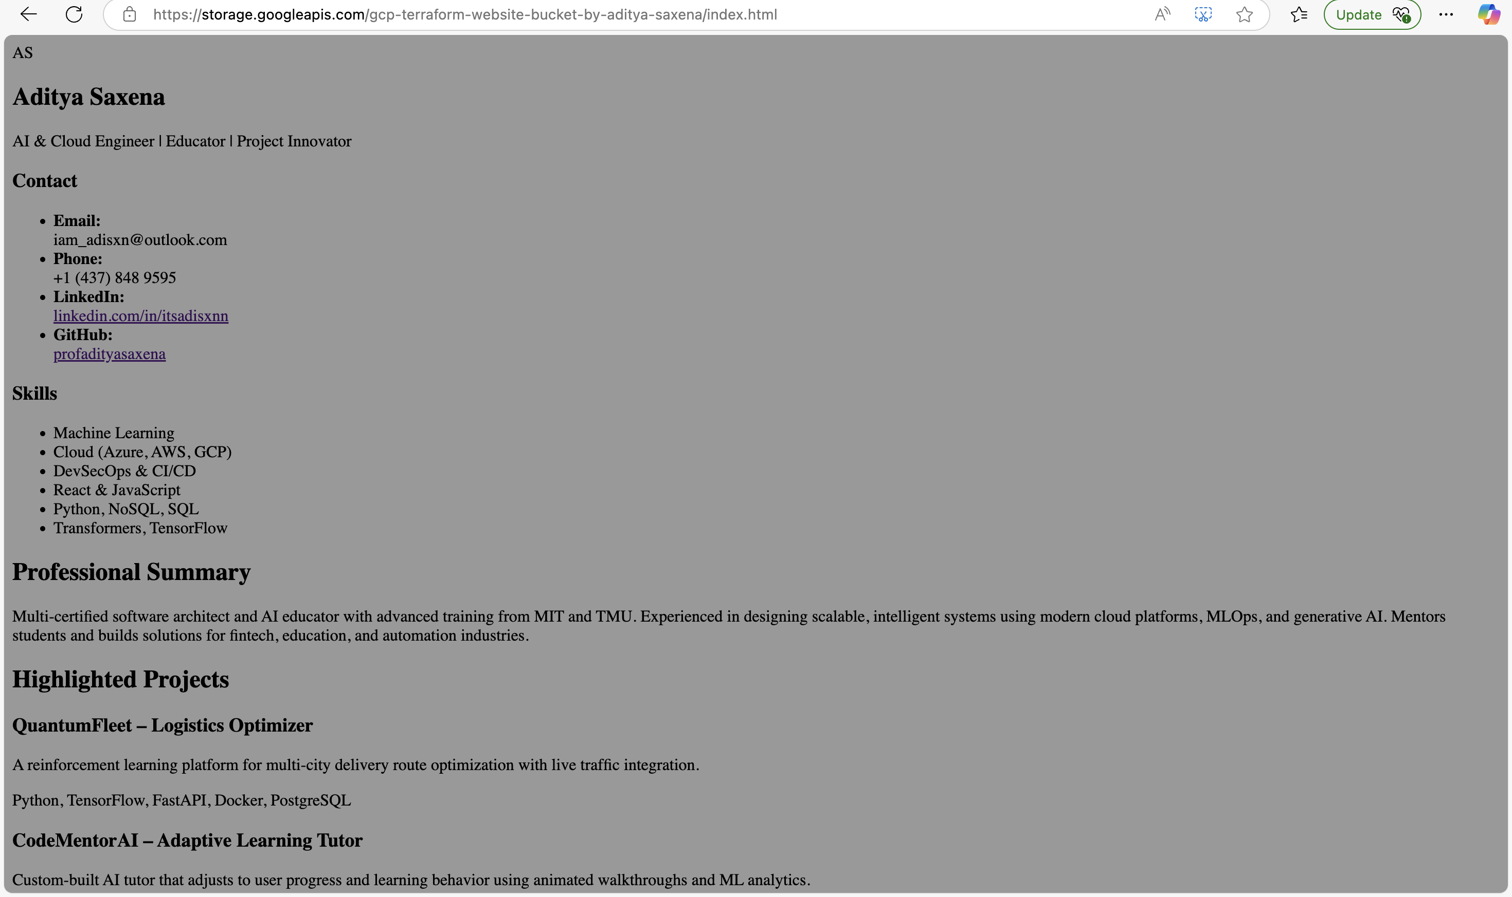

## Step 8.1 Changing MIME Type

We correct MIME types for CSS and JS files to ensure the browser interprets them properly. This is important for styling and interactivity of the static site.

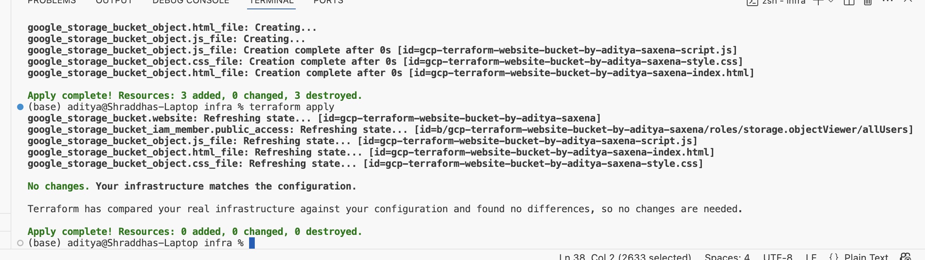

## Step 8.2 Javascript MIME Type

This screenshot represents an important step in the Terraform deployment workflow.

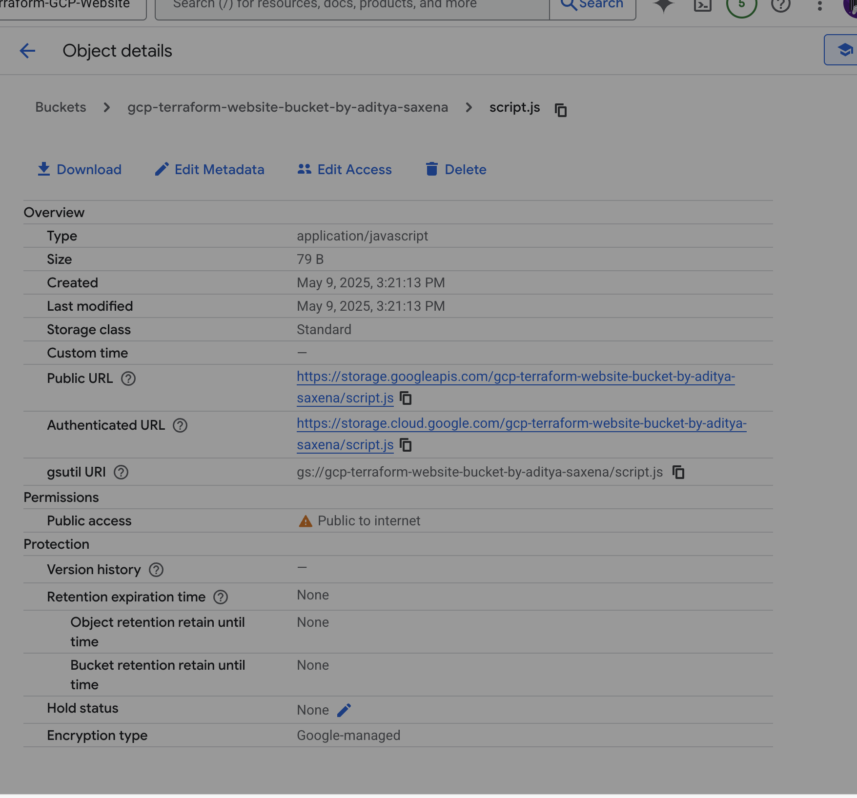

## Step 8.3 CSS MIME Type

This screenshot represents an important step in the Terraform deployment workflow.

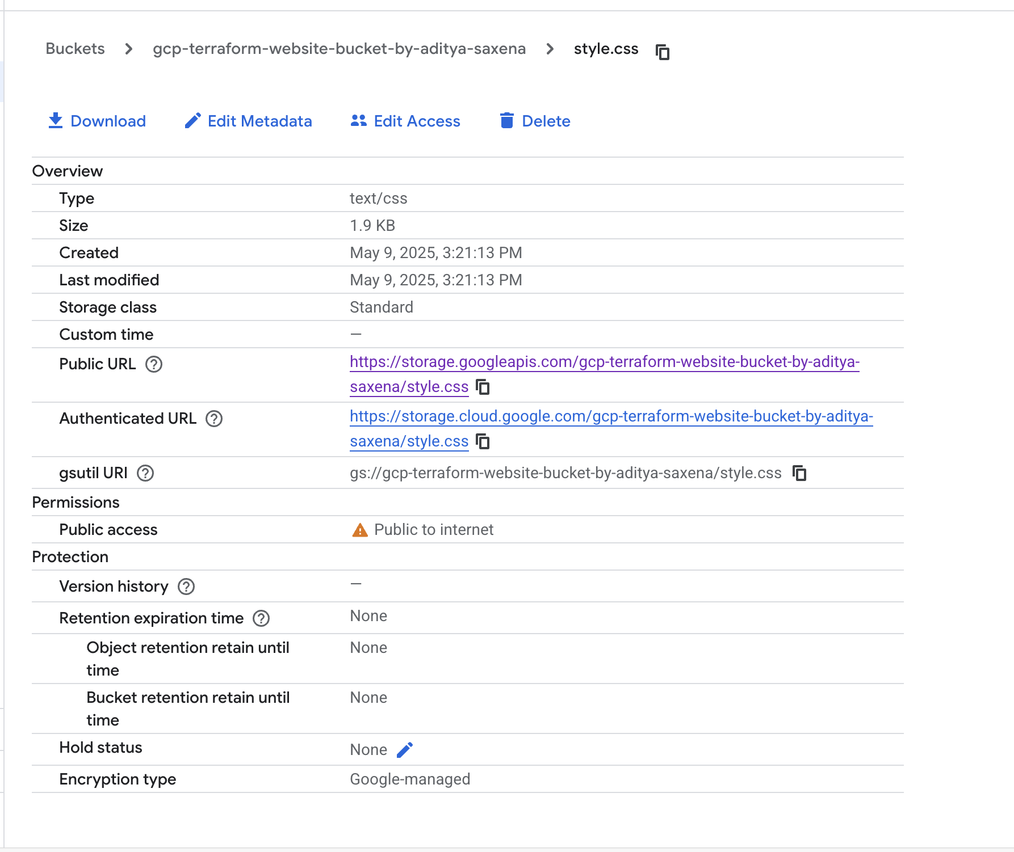

## Step 8.4 Taint and Apply

We use the `terraform taint` command to force Terraform to re-upload specific files. This is useful when metadata such as MIME type changes without changing the file content.

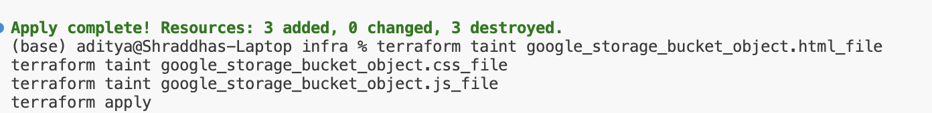

## Step 9.1 Result

This screenshot confirms the successful deployment of the website. The domain is publicly accessible, styled, interactive, and protected with HTTPS.

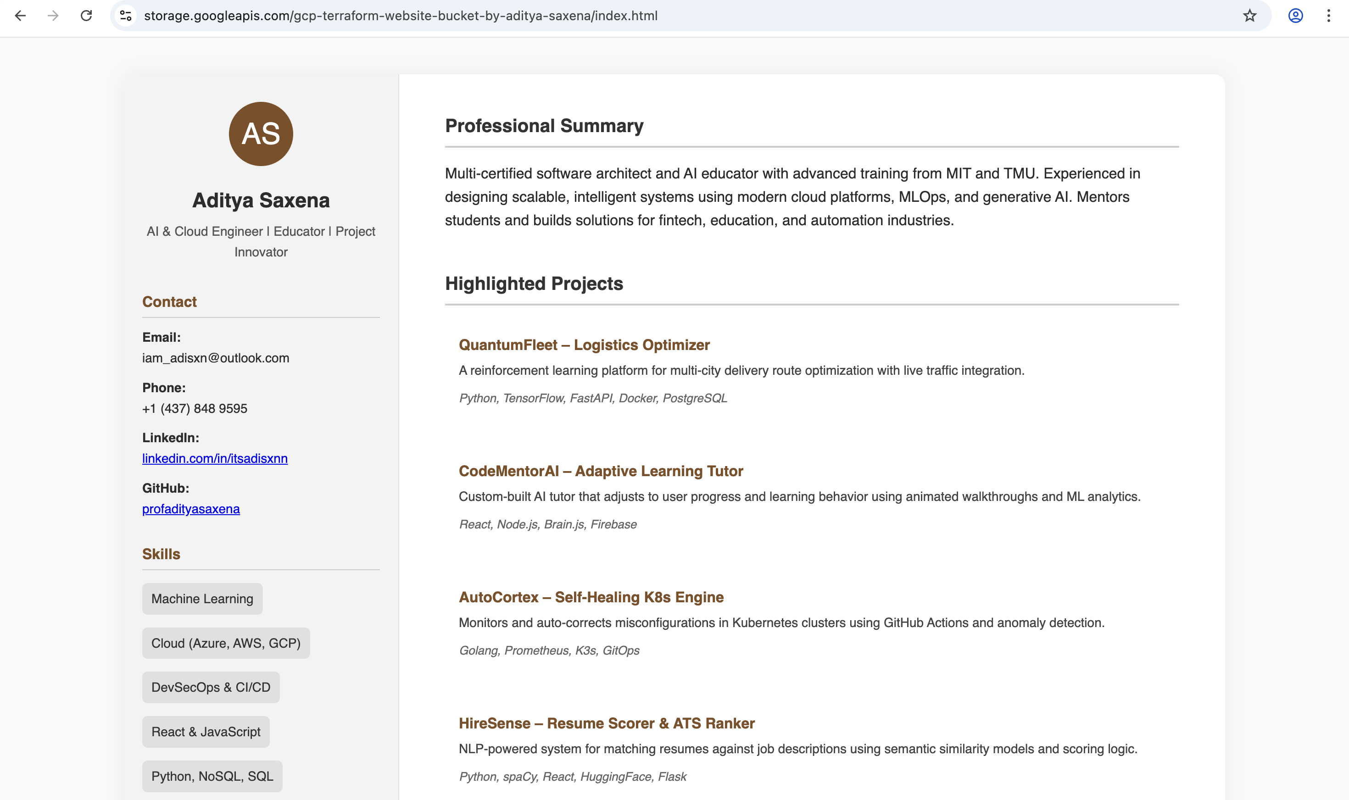

## Step 10.1 Configuring DNS

DNS records are configured in GCP Cloud DNS to route `gcp.adityasaxena.xyz` to the reserved static IP. This step enables domain-based access to the site.

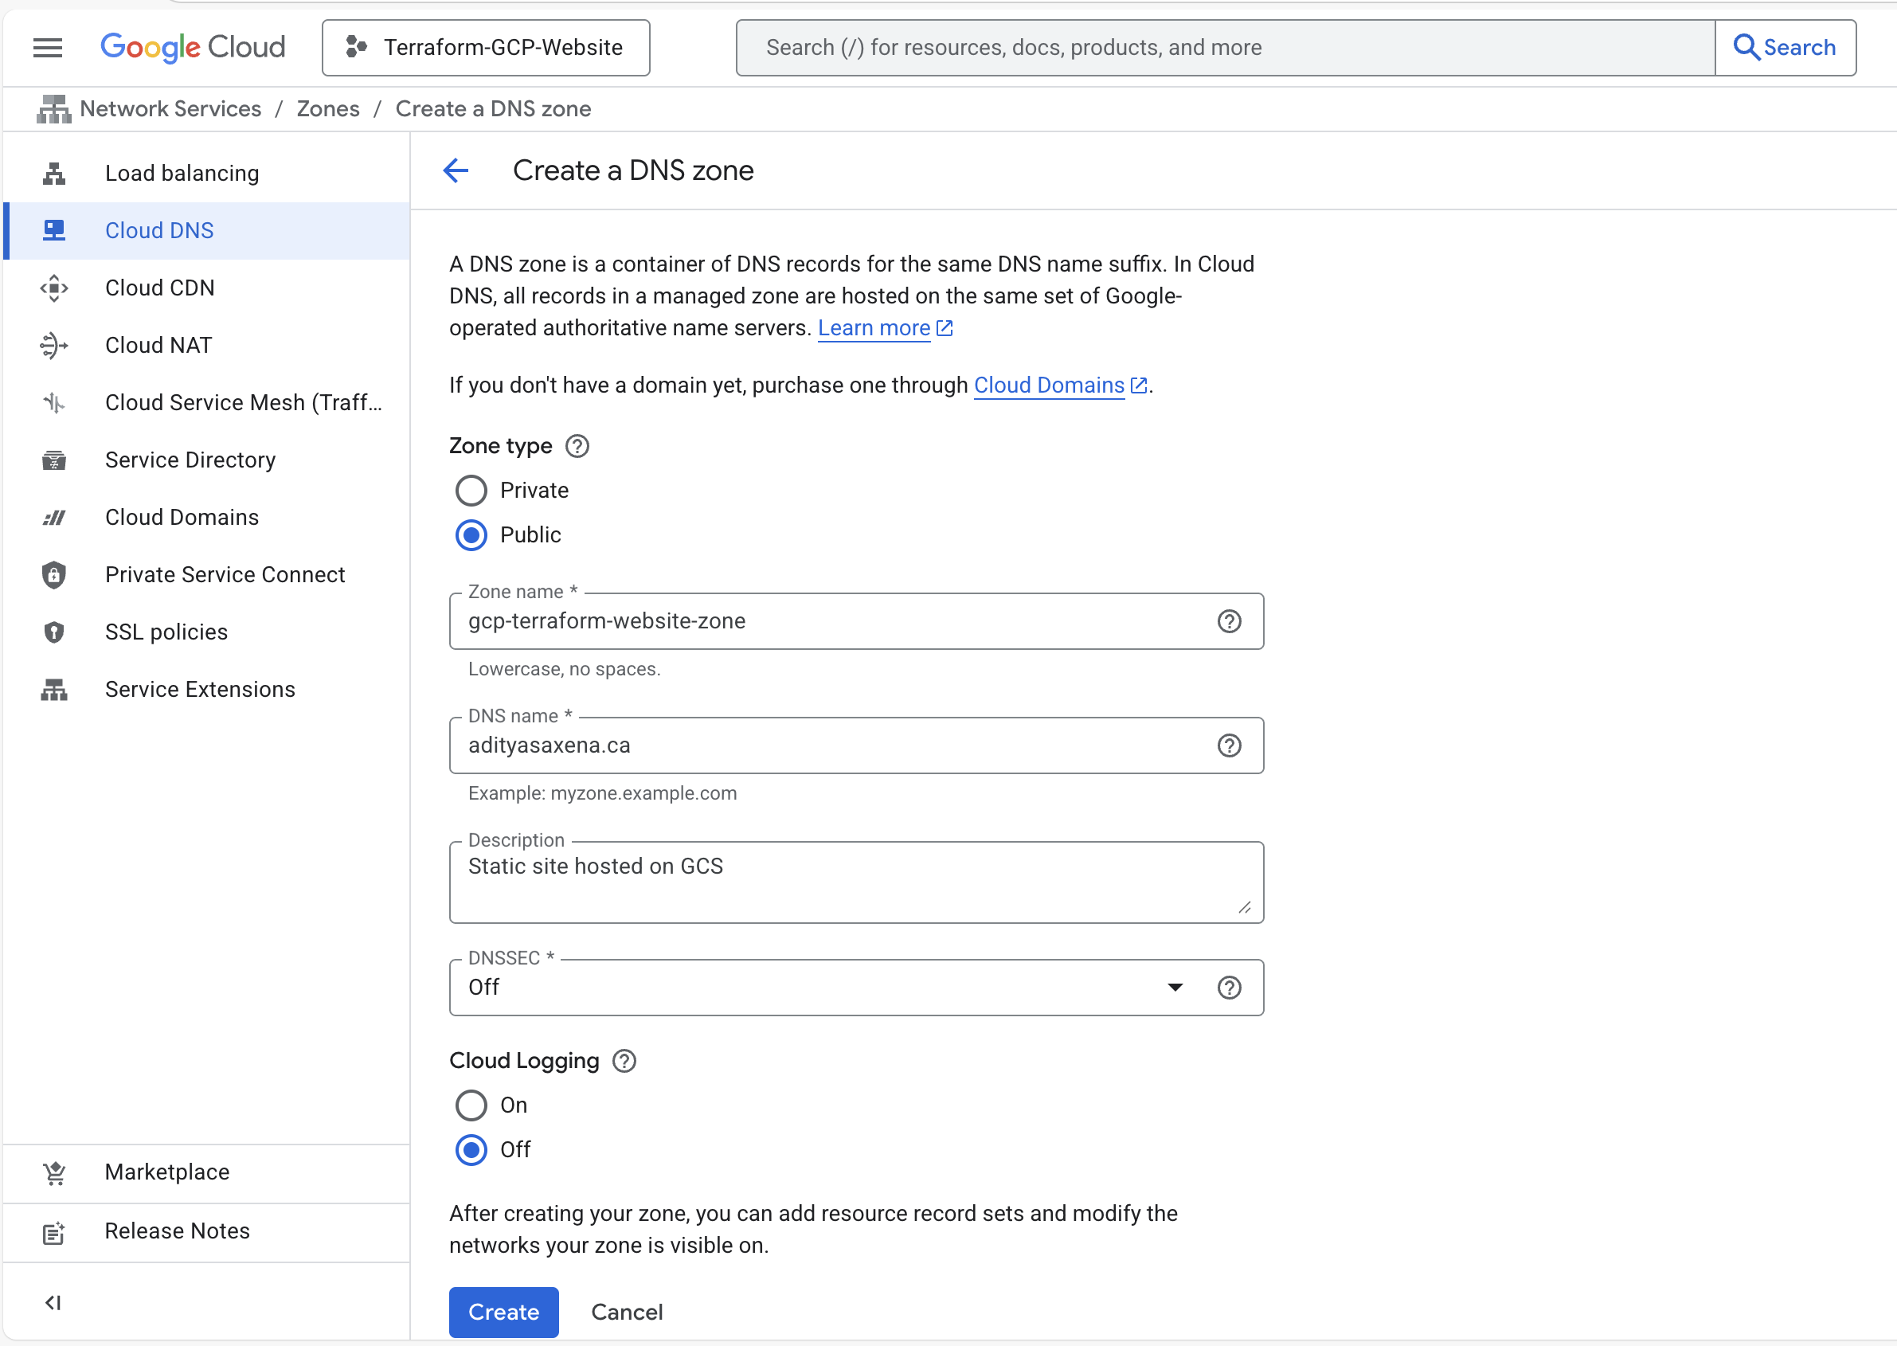

## Step 10.2 Configuring DNS

DNS records are configured in GCP Cloud DNS to route `gcp.adityasaxena.xyz` to the reserved static IP. This step enables domain-based access to the site.



## Step 11.1 Terraform Init and Plan

This screenshot represents an important step in the Terraform deployment workflow.

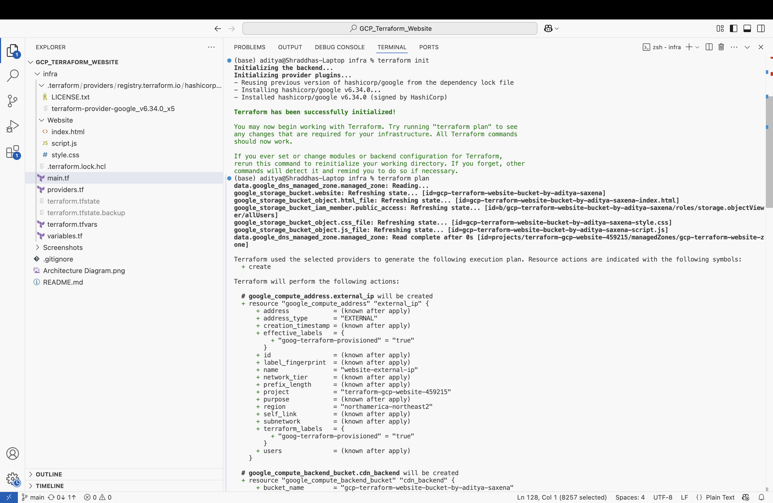

## Step 11.2 Terraform Plan

The `terraform plan` command is used to preview the infrastructure changes that will be applied. This helps catch potential errors before provisioning.

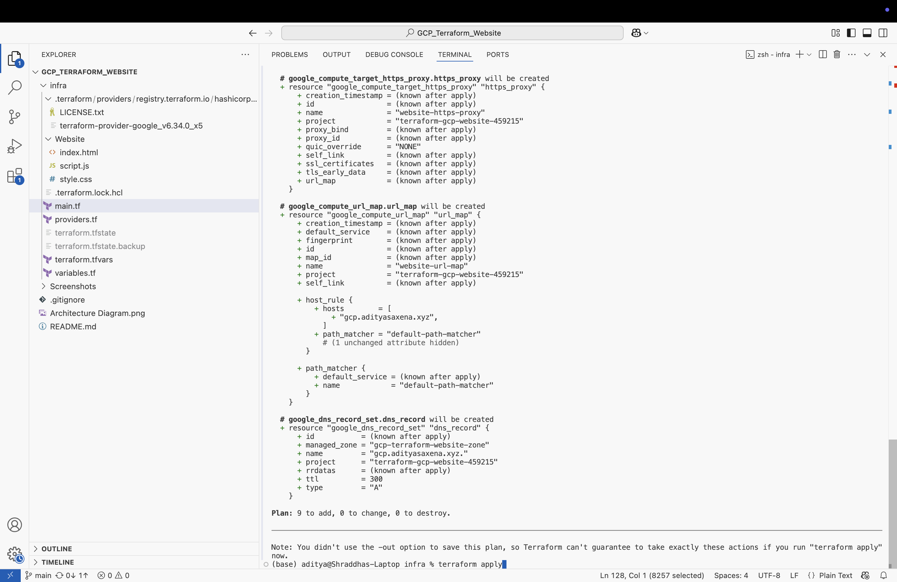

## Step 11.3 Terraform Apply

In this step, we run `terraform apply` to provision the actual resources. This includes setting up the storage bucket, IAM policies, CDN, and DNS configuration.

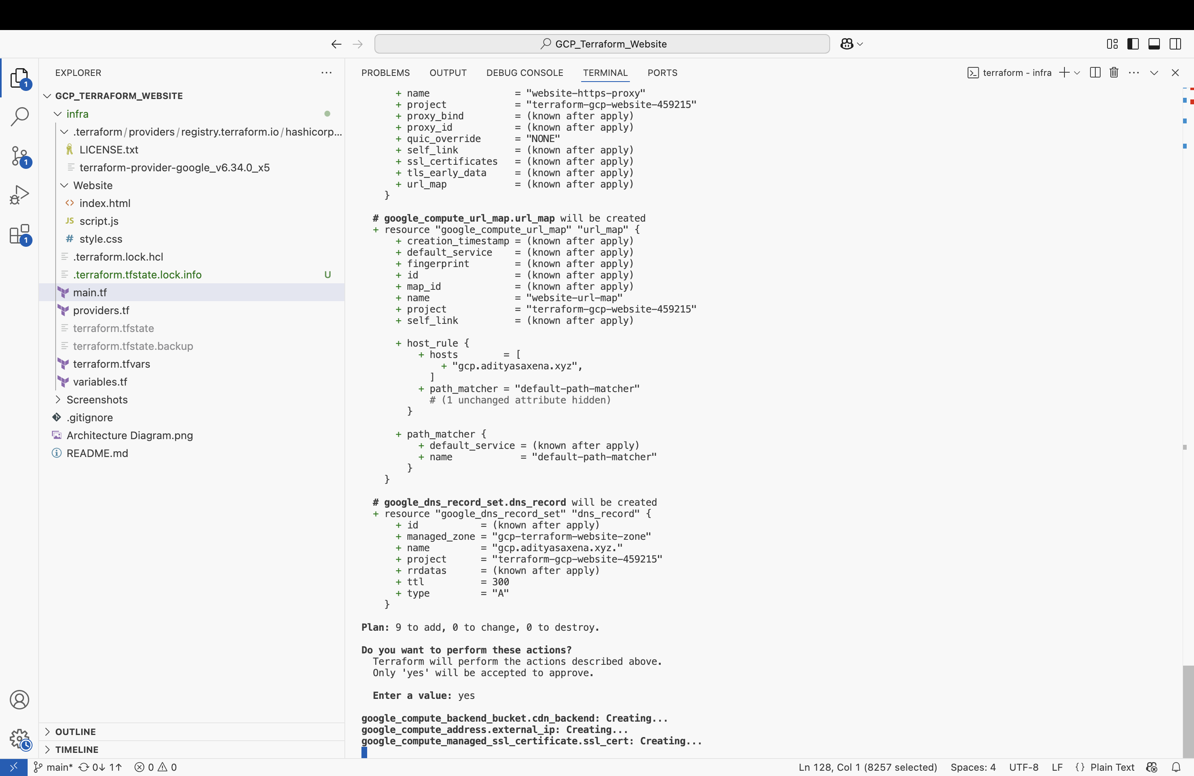

## Step 11.4 Changing Nameservers

Nameservers are updated in GoDaddy to delegate DNS control to Google Cloud. Without this, GCP DNS configurations would have no effect on the domain.

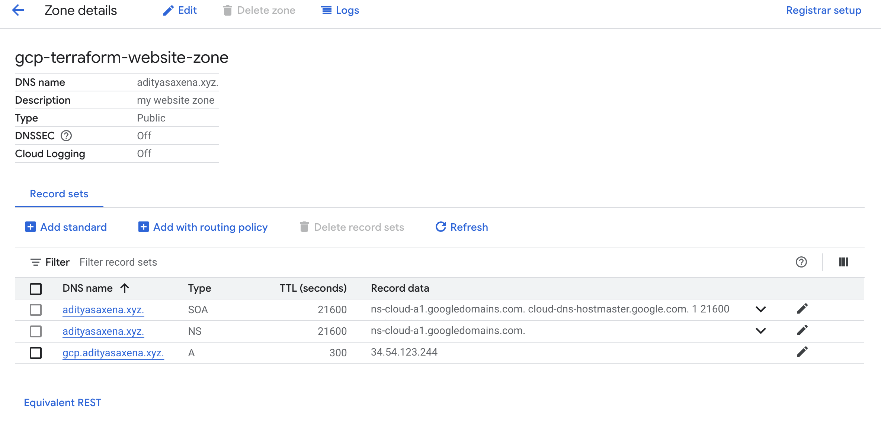

## Step 11.5 Terraform Apply Complete

In this step, we run `terraform apply` to provision the actual resources. This includes setting up the storage bucket, IAM policies, CDN, and DNS configuration.

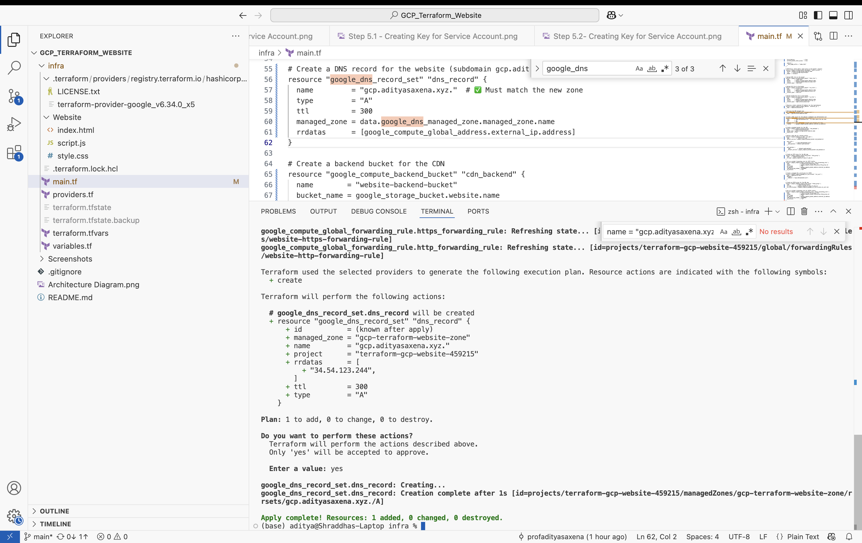

## Step 11.6 Checking DNS Propogation

We check if DNS changes have propagated globally using tools like `dig`. Once propagated, requests to the domain will resolve to the GCP-hosted IP.

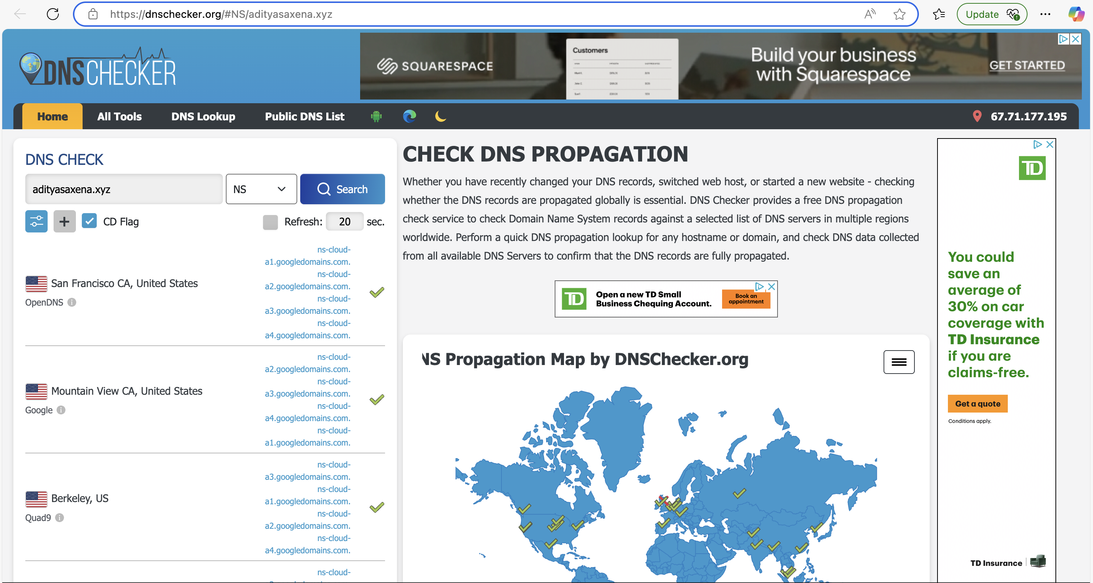

## Step 11.7 Checking Website in Production Environment

This screenshot shows the live website served via Google Cloud CDN and load balancer. It confirms that all infrastructure components are working as expected.

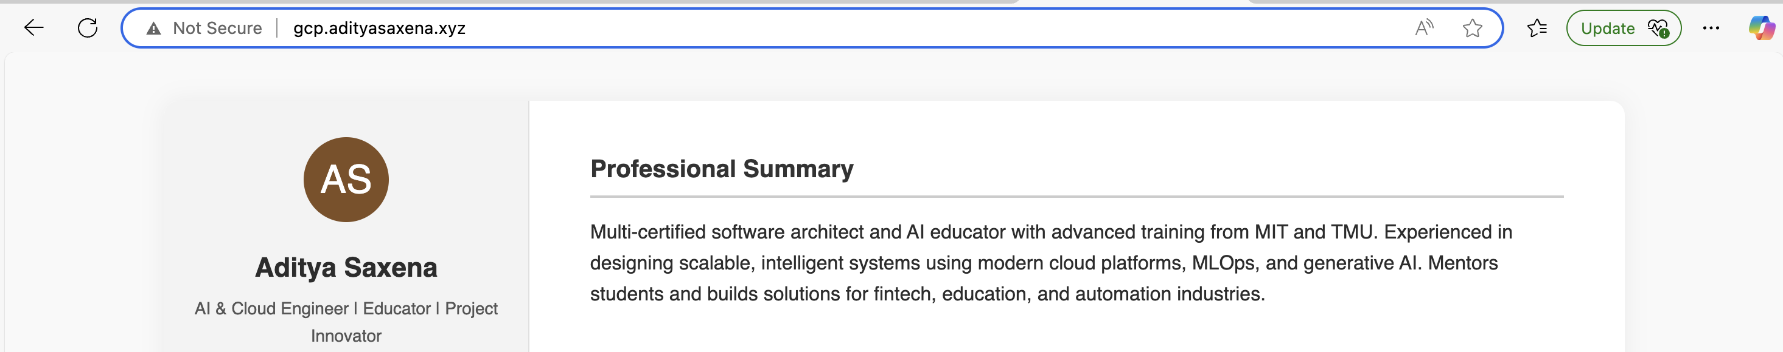

## Step 11.8 Checking Free SSL Certificate

We validate that a Google-managed SSL certificate has been issued for the domain. This provides encrypted HTTPS traffic to the site with no manual renewals needed.

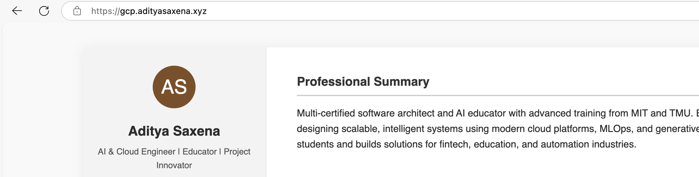

## Step 11.9 Checking Load Balancer

We inspect the GCP Load Balancer configuration to ensure it's set up properly. Load balancing enables high availability and global content delivery.

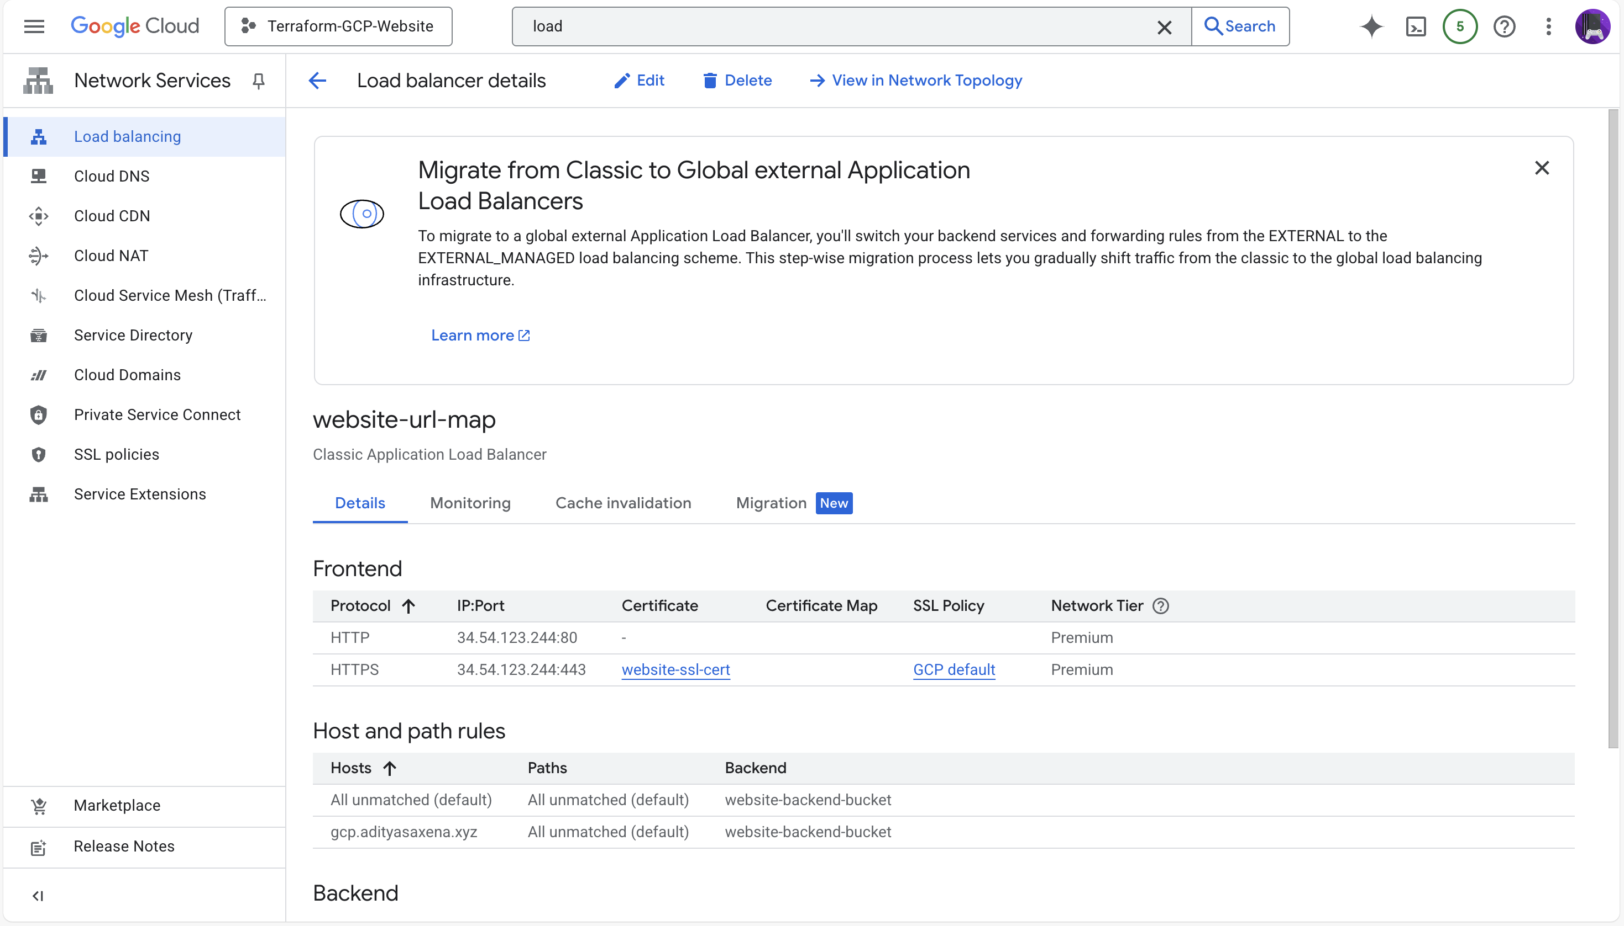

## Step 12.1 Terraform Destroy

Finally, we run `terraform destroy` to remove all infrastructure. This is a good practice to avoid unnecessary billing and maintain a clean cloud environment.

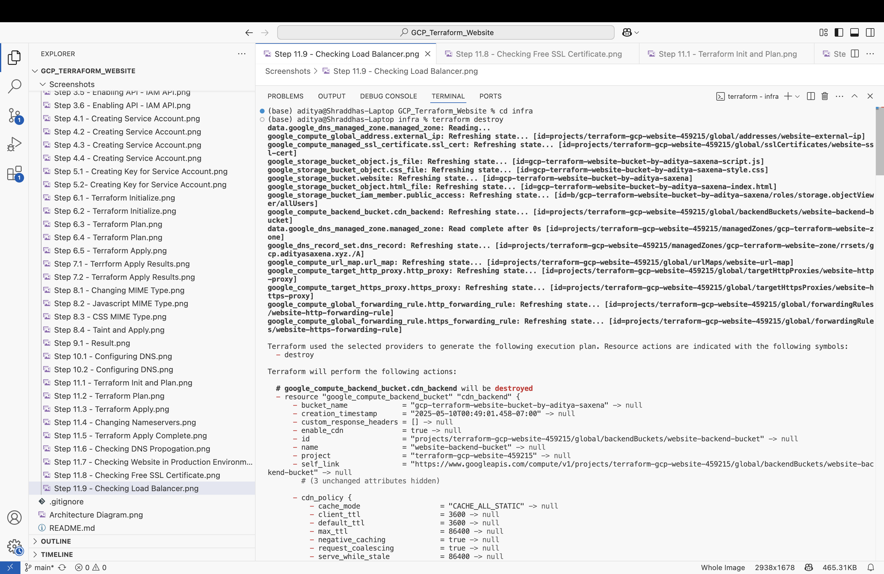

## Step 12.2 Terraform Destroy

Finally, we run `terraform destroy` to remove all infrastructure. This is a good practice to avoid unnecessary billing and maintain a clean cloud environment.

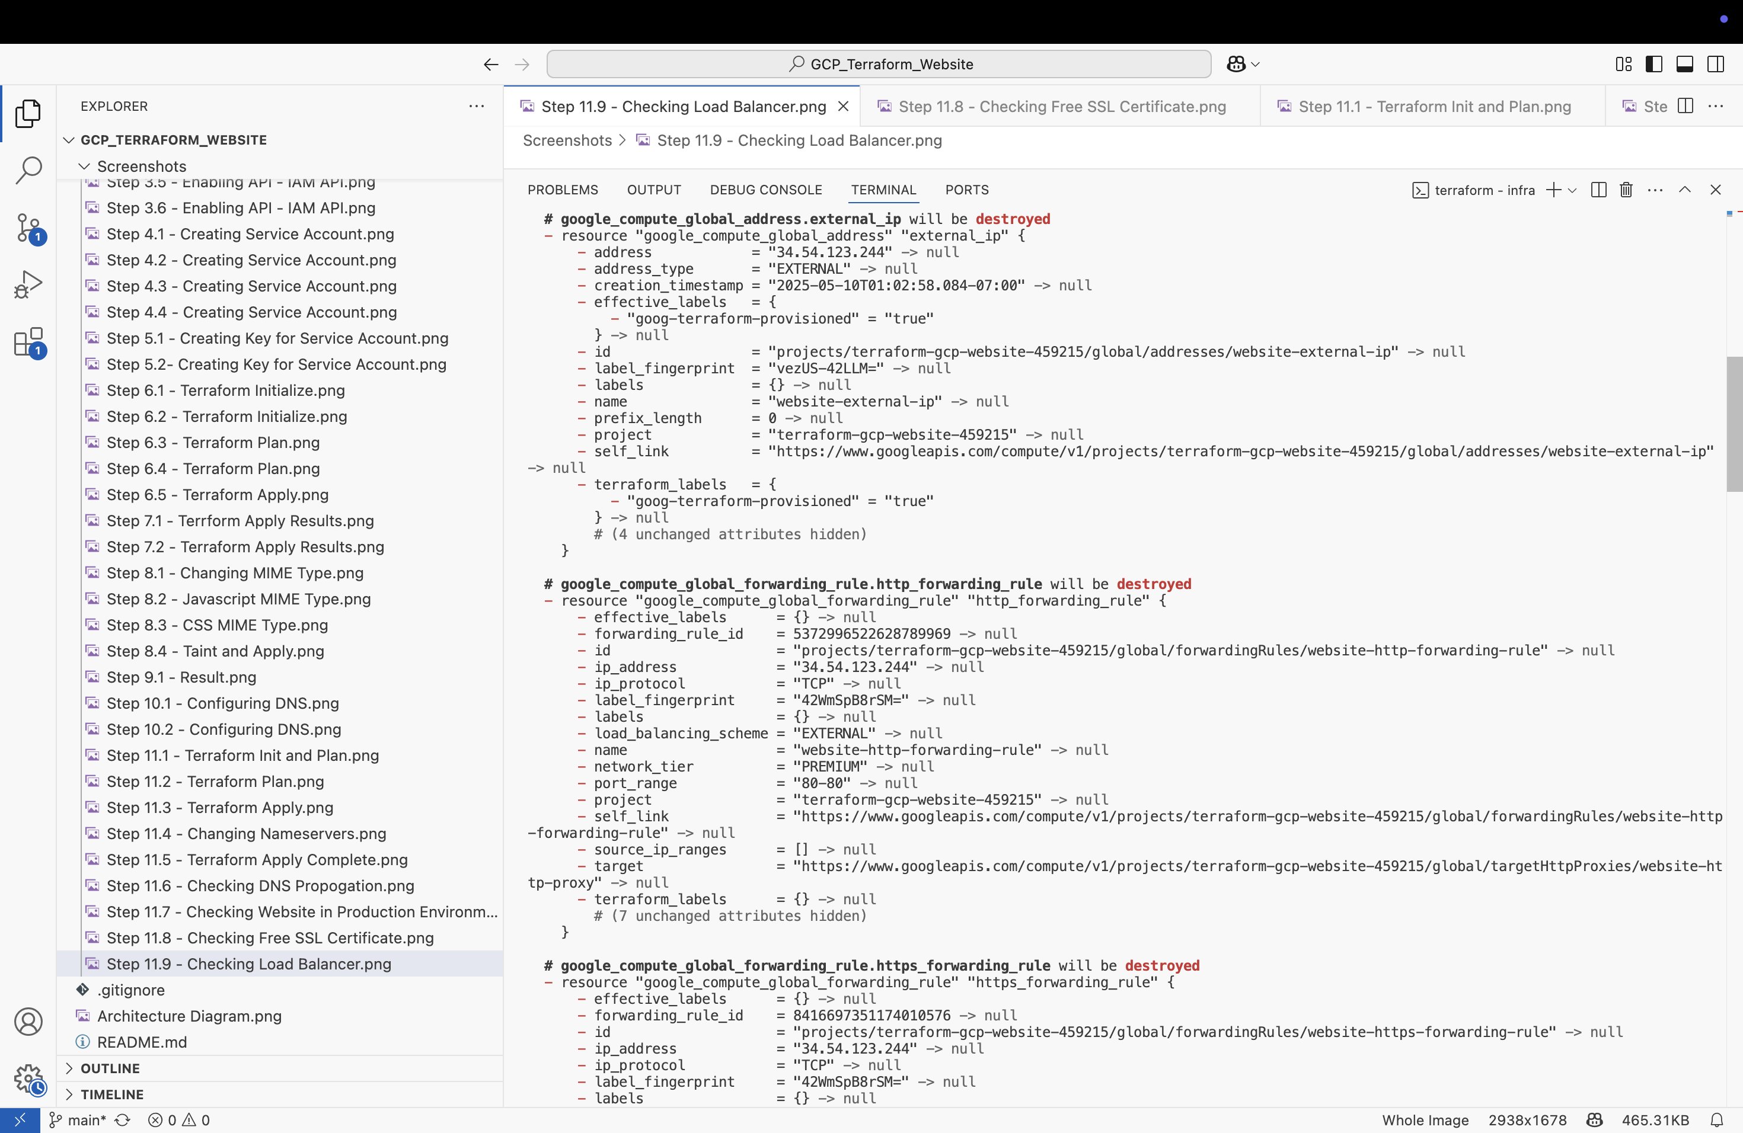

## Step 12.3 Terraform Destroy

Finally, we run `terraform destroy` to remove all infrastructure. This is a good practice to avoid unnecessary billing and maintain a clean cloud environment.

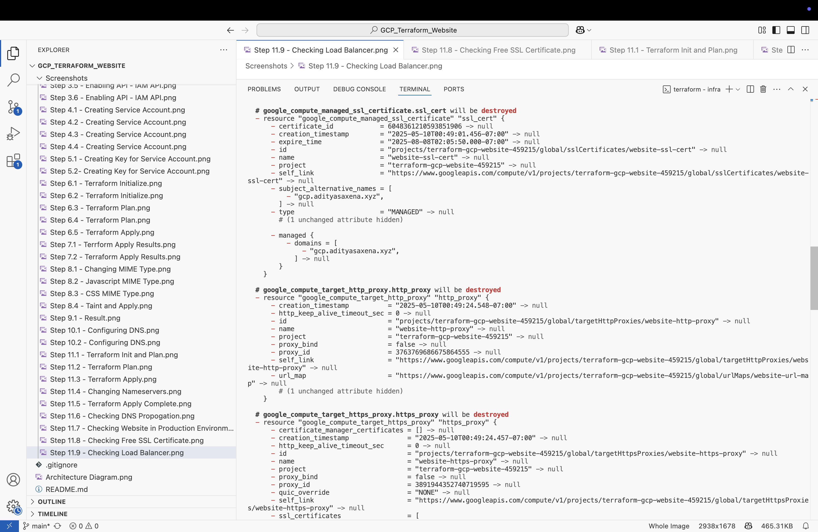

## Step 12.4 Terraform Destroy

Finally, we run `terraform destroy` to remove all infrastructure. This is a good practice to avoid unnecessary billing and maintain a clean cloud environment.

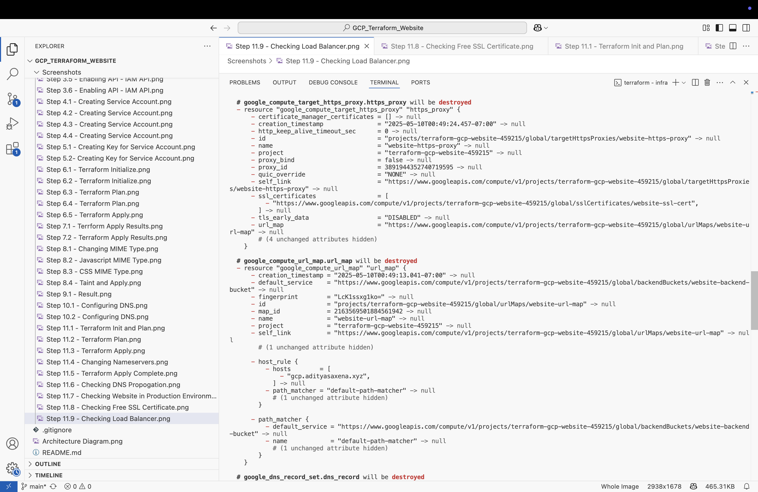

## Step 12.5 Terraform Destroy

Finally, we run `terraform destroy` to remove all infrastructure. This is a good practice to avoid unnecessary billing and maintain a clean cloud environment.

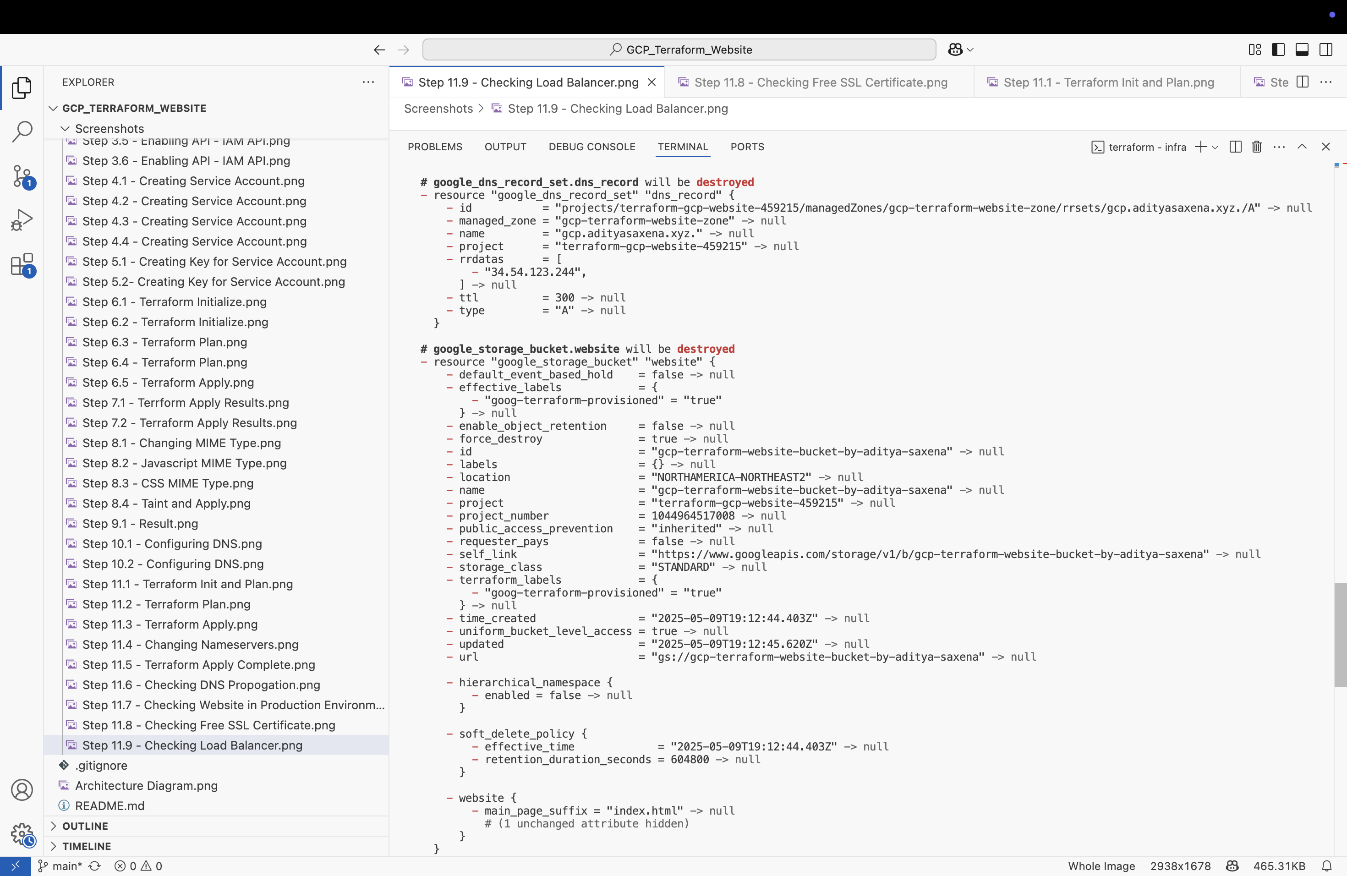

## Step 12.6 Terraform Destroy

Finally, we run `terraform destroy` to remove all infrastructure. This is a good practice to avoid unnecessary billing and maintain a clean cloud environment.

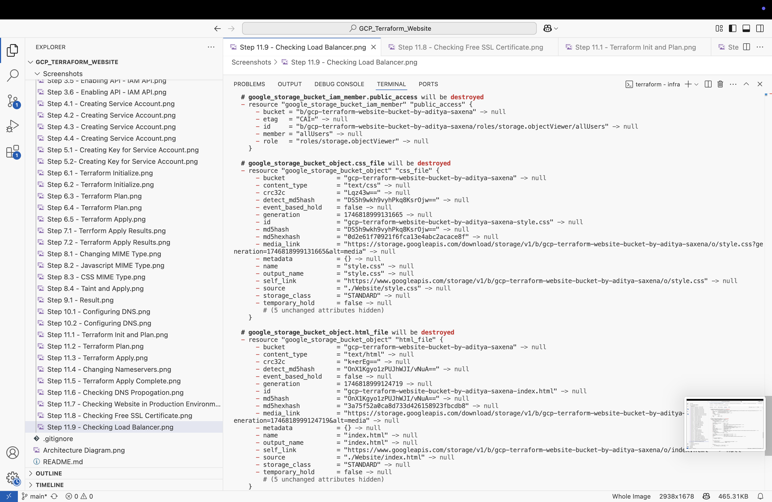

## Step 12.7 Terraform Destroy

Finally, we run `terraform destroy` to remove all infrastructure. This is a good practice to avoid unnecessary billing and maintain a clean cloud environment.

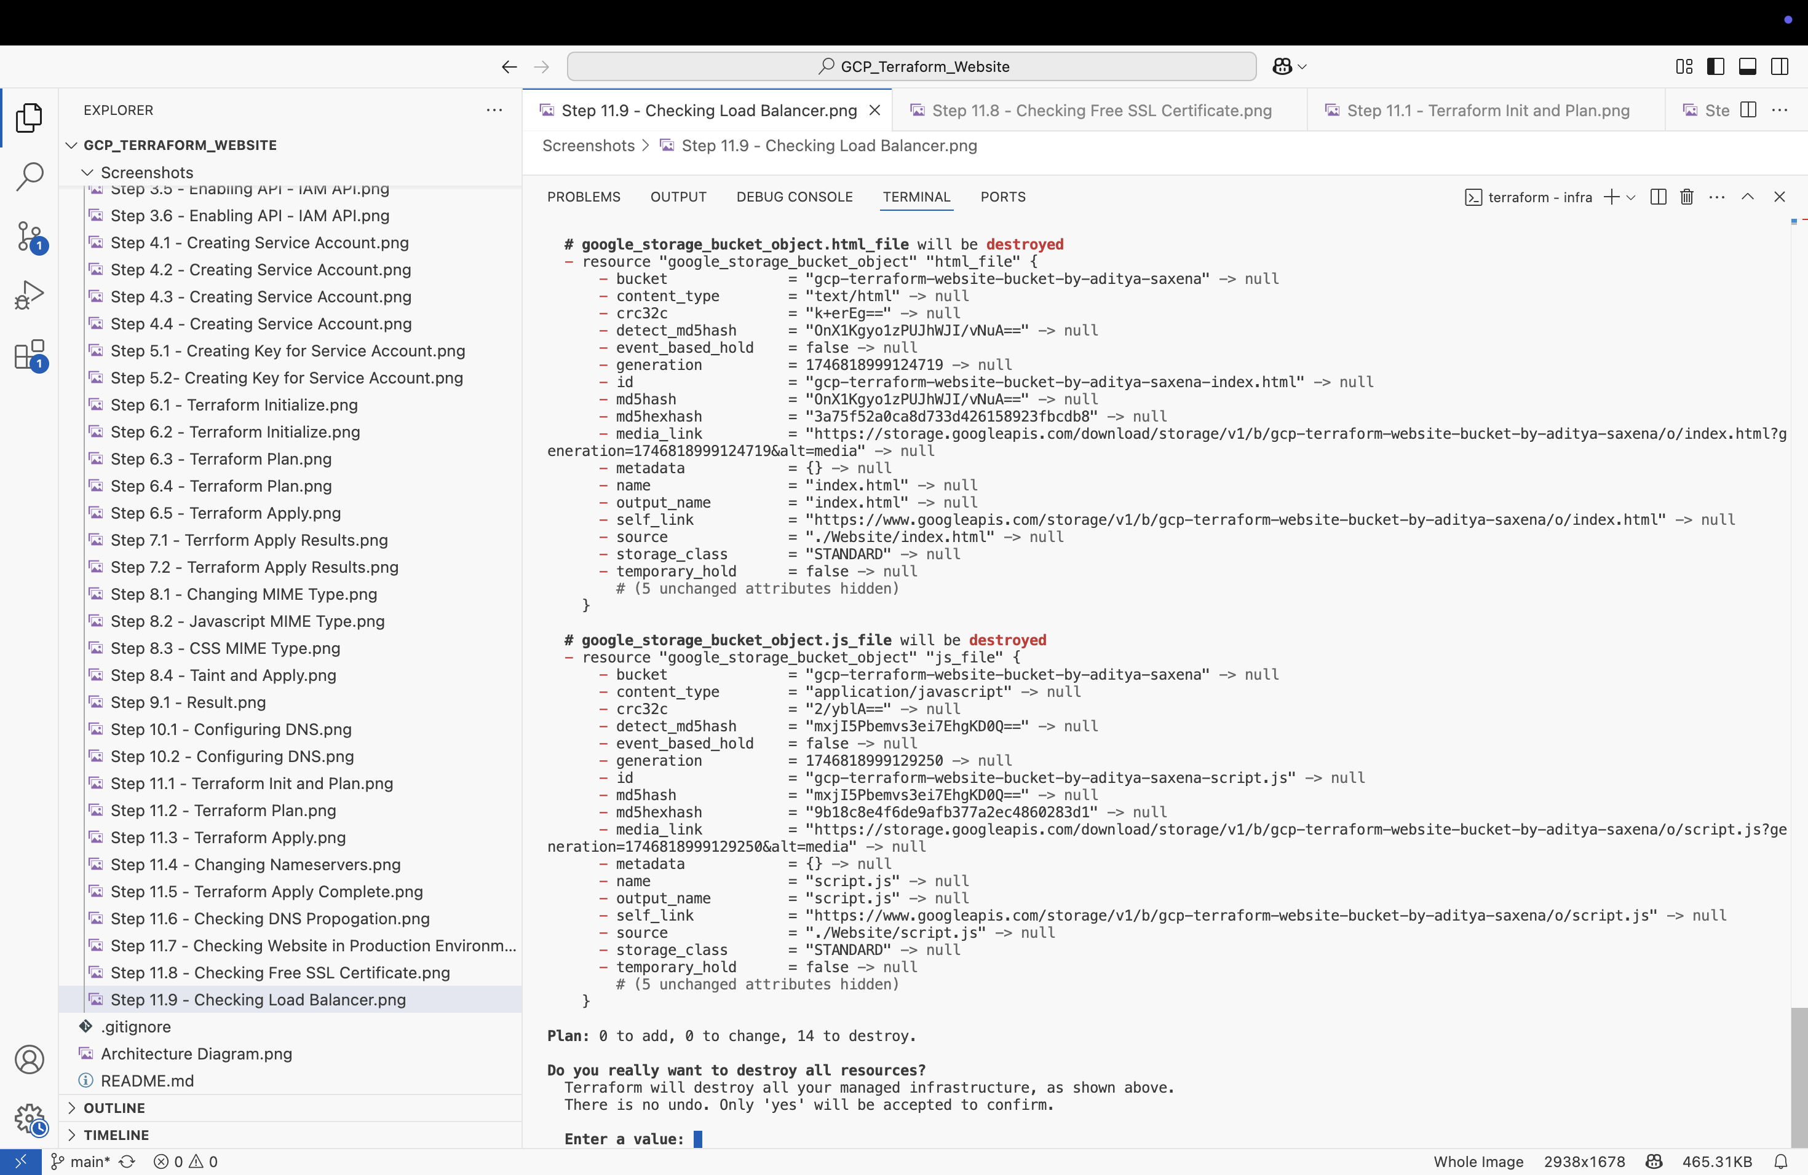

## Step 12.8 Terraform Destroy

Finally, we run `terraform destroy` to remove all infrastructure. This is a good practice to avoid unnecessary billing and maintain a clean cloud environment.

